**COMPLETED DESCRIPTION**

**BULBS**

Halonix Inverter Led Bulb B22 9-Watt (Power Backup Upto 4 Hours),White

$25

##### **Technical Details**

Brand: Halonix

Product Code: F2JMM4WP9009U00

Number of Items: 1

Style: Pack of 1

Colour: White

Material: Polycarbonate

Included Components: LED Bulb

Batteries Included: Yes

Batteries Required: Yes

Type of Bulb: LED

Cap Type: B22

Luminous Flux: 900 Lumens

Wattage: 9 Watts

Colour Temperature: 6500 Kelvin

##### **Description**

• Includes: LED Bulb

• Wattage: 9 watts

• Warranty: 1 year on product from date of invoice

• A Perfect Emergency/Rechargeable Bulb

• Automatically Lights Up When Grids(Main) Power Supply Fails

• With Auto-Charge Technology

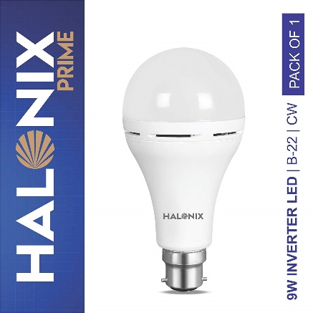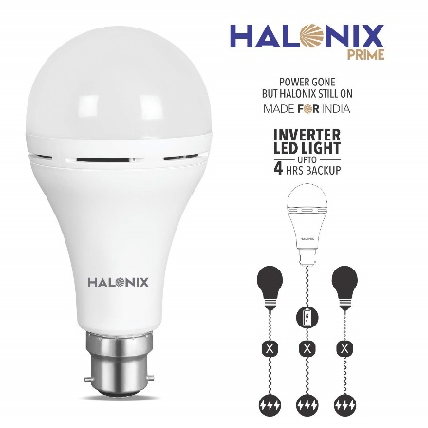• Charging time 8-10 hours

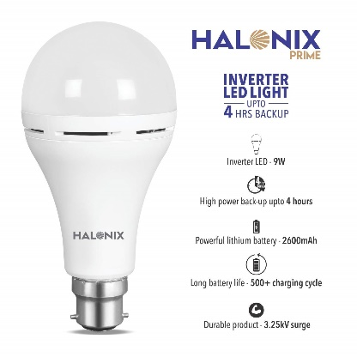

Cree 40W Equivalent Soft White (2700K) A19 LED Light Bulb 4 Pack

$10

##### **Technical Details**

Product Code: BA19-04527OMF

Item Weight : 3.84 ounces

Product Dimensions : 2.4 x 2.4 x 4.4 inches

Color : White

Style : 40W Equivalent Soft White (2700K)

Shape: A19

Power Source : corded-electric

Voltage : 120 volts

Wattage : 6

Type of Bulb : LED

Luminous Flux: 450

Certification : Energy Star;UL Listed

Usage: Indoor/Outdoor (UL Damp Rated)

Batteries Included : No

Batteries Required : No

Warranty Description: 10-years limited warranty; see package for details.

##### **Description**

• 4 bulb multi-pack of General purpose LED bulb for every space in your home - The Cree LED Bulb looks and lights just like an incandescent bulb

• 40W equivalent uses only 6 Watts (85% less energy than a traditional incandescent), saving you $94 in energy costs over the life of the bulb

• Dimmable with most standard dimmers

• Lights instantly and provides an all-around, omnidirectional light distribution - just like an incandescent bulb

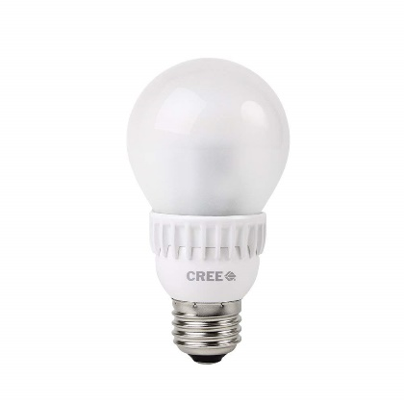• 25,000 hours of beautiful, warm, energy-efficient light - compared to just 1,000 hours for a traditional incandescent bulb

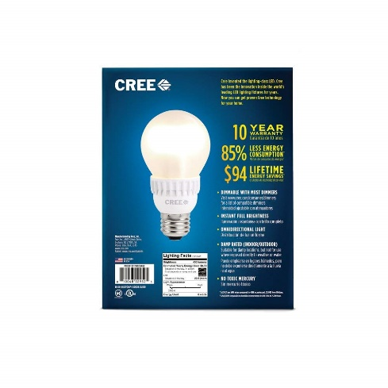

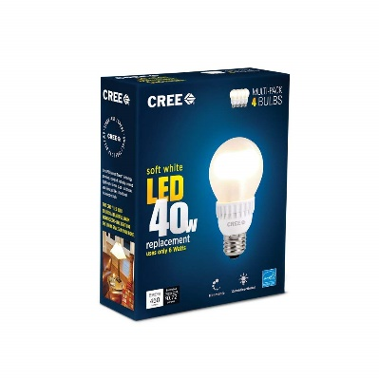

#### Wipro Garnet 3-Watt LED Bulb

$12.50

##### **Technical Details**

Brand :Wipro

Product Code: N32001

Weight: 118 Grams

Number of Items : 1

Colour: Cool Day Light

Material: Polycarbonate

Included Components: 1 LED Bulb

Power and Plug Description :electric

Batteries Included :No

Batteries Required :No

Type of Bulb: LED

Cap Type: B22

Luminous Flux: 250 Lumens

Wattage : 3 Watts

Colour Temperature: 6500 Kelvin

**Description**

• Color Temperature: 6500K, Lumens: 250Lm

• 90 percent brighter than CFL equivalent wattage

• Relace 25 watts GLS bulb with 85 percent energy saving

• Replace 5 watts CFL with 40 percent energy saving

• Long life upto 10 years

• No effect of voltage fluctuation (100-300VAC)

• Warranty: 1 year from date of invoice (See below on how to claim warranty)

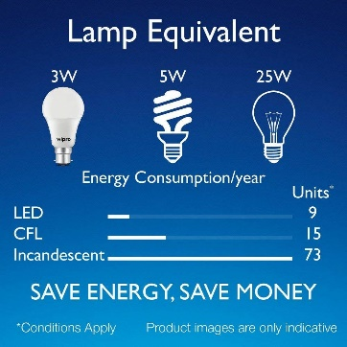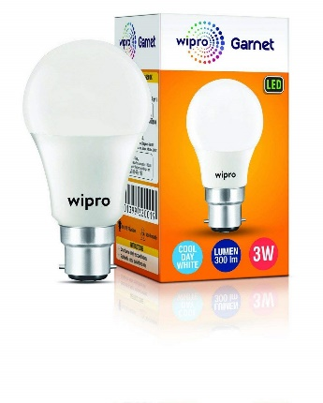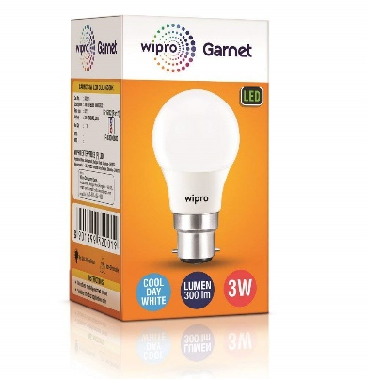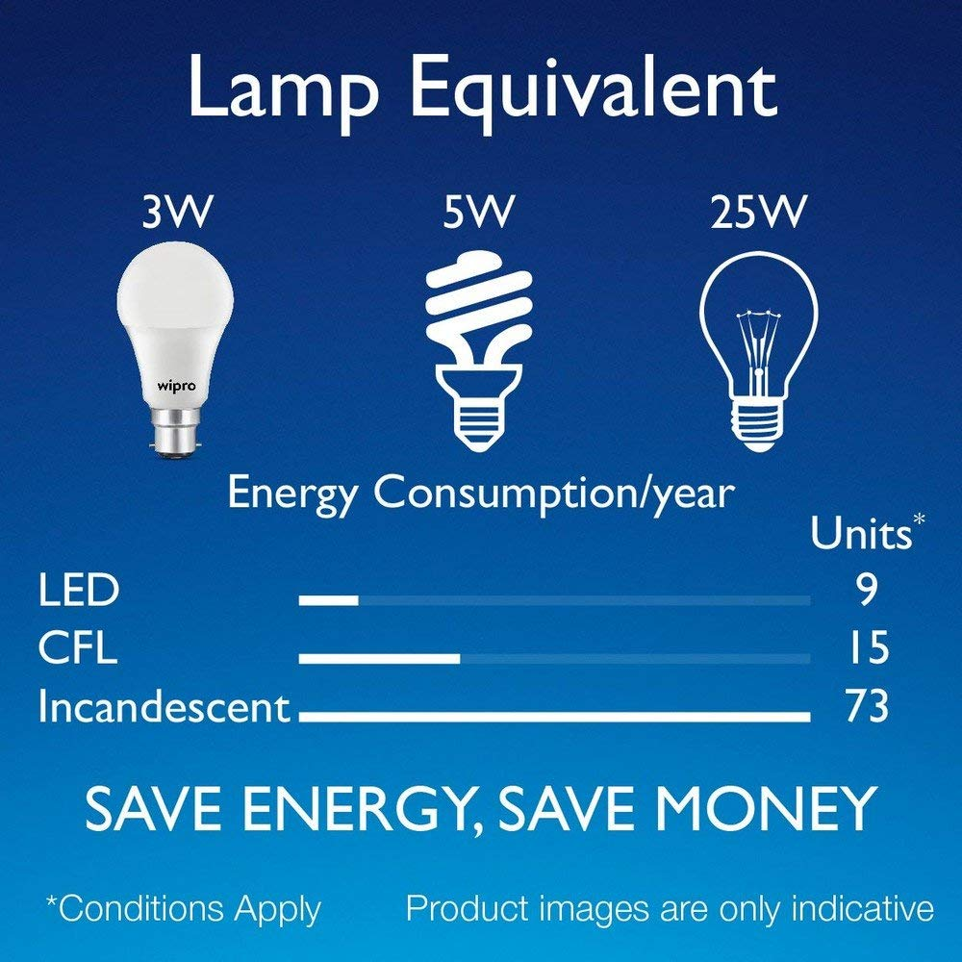

#### Philips Stellar Bright Base B22 27-Watt LED Bulb (White)

$34

##### **Technical Details**

Product Code: B200-KOPP

Brand: Philips

Height: 14 Centimeters

Length: 40 Millimeters

Width: 40 Millimeters

Weight: 272 Grams

Number of Items: 1

Colour: White

Shape: Round

Material: Polycarbonate

Included Components: 1 LED Bulb

Batteries Included: No

Batteries Required: No

Type of Bulb: LED

Cap Type: B22

Luminous Flux: 2700 Lumens

Wattage: 27 Watts

Bulb Features: Non adjustable

Colour Temperature: 6500 Kelvin

**Description**

• 4 bulb multi-pack of General purpose LED bulb for every space in your home - The Cree LED Bulb looks and lights just like an incandescent bulb

• 40W equivalent uses only 6 Watts (85% less energy than a traditional incandescent), saving you $94 in energy costs over the life of the bulb

• Dimmable with most standard dimmers

• Lights instantly and provides an all-around, omnidirectional light distribution - just like an incandescent bulb

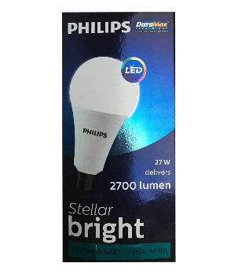• 25,000 hours of beautiful, warm, energy-efficient light - compared to just 1,000 hours for a traditional incandescent bulb

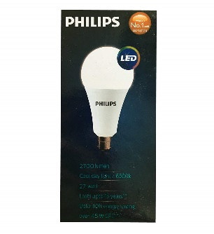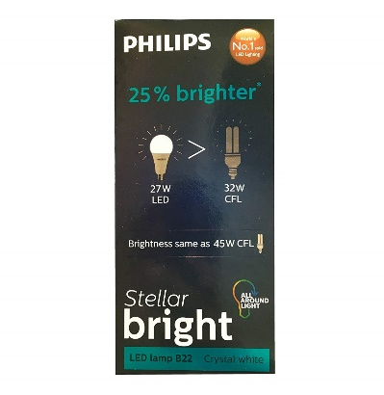

#### iMee 7 Watts 700 Lumens High Power Factor LED Bulb 6500K (Cool Day Light), LED Powered by Edison LED (Taiwan), Nickel Plated B22 Base (Pack of 2)

$75

##### **Technical Details**

Brand: iMee

Product code: MEE-SG-7W-6500K-PO2

Colour: Cool Day Light (6500K)

Material: Metal

Batteries Included: No

Batteries Required: No

Cap Type: B22

Wattage: 7 Watts

Colour Temperature: 6500 Kelvin

**Description**

• LED Powered By EDISON Taiwan, Best in Class Super Brightness level of 100 Lumens Per Watt

• With Aluminium Cup Coating from Inside, High Power Factor 0.95, Surge Protection Upto 2.5Kv

• With Nickel Plated Aluminium Holder & High Grade White Colour Holder not like Inferior Black Colour Holder

• Wide Operating Voltages, No Mercury & Lead, Environment Friendly, Excellent CRI upto 80%, Operating Temp: -10 degC to 50 degC, Fluctuation Proof & Anti Glare Light, Upto 50,000 Burning Hours Life Expectancy

• Have any questions? LIVE chat with experts at www.imee.in for any assistance ! 2 Years Seller And Manufacturer Warranty

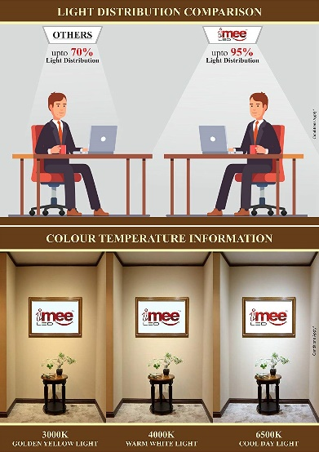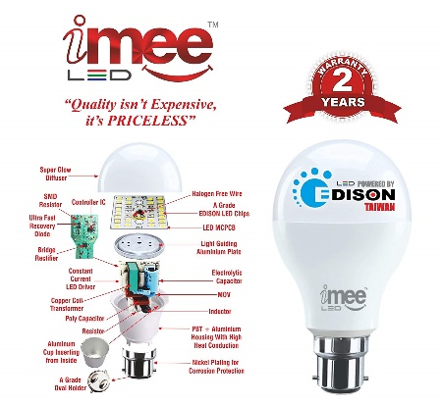

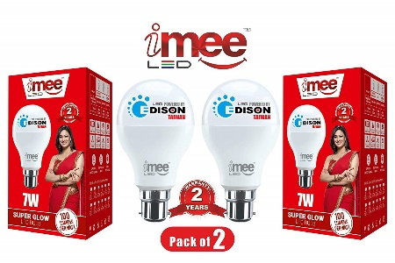

#### Philips Deco Ring Base B22 10-Watt LED Bulb (Pack of 2, Cool Day Light)

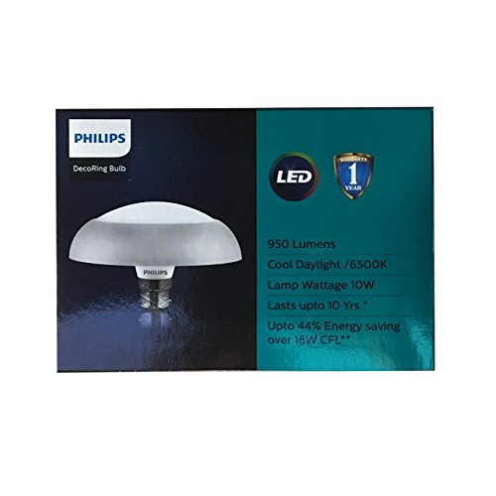$35

##### **Technical Details**

Brand: Philips

Product code: 5798-1233NW

Height: 10.5 Centimeters

Length: 20 Centimeters

Width: 31 Millimeters

Style: Art Deco

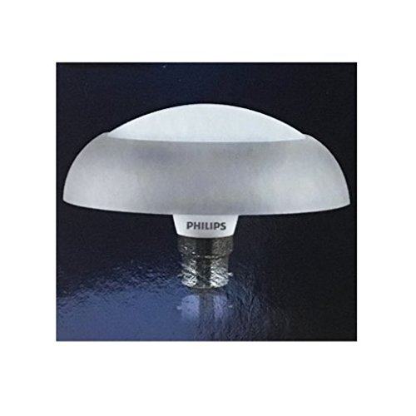 Colour: Cool Day Light

Shape: Round

Material: Polycarbonate

Included Components: 2 LED Bulbs

Voltage: 230 Volts

Shade Colour: White

Shade Material: Polycarbonate

Power and Plug Description: corded-electric

Batteries Included: No

Batteries Required: No

Type of Bulb: LED

Cap Type: B22

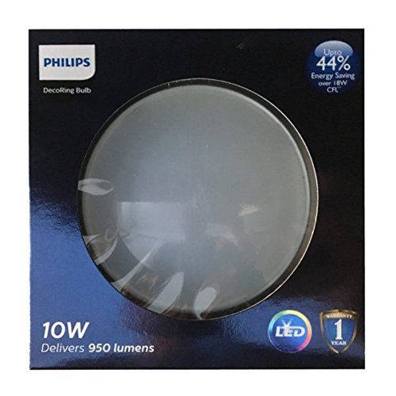 Luminous Flux: 950 Lumens

Wattage: 10 Watts

Bulb Features: Energy saving, direct replacement for a regular LED bulb

Colour Temperature: 6500 Kelvin

Average Life: 15000 Hours

Average Life: 15000 Hours

##### **Description**

• Includes: LED Bulb

• Wattage: 10 watts

• Warranty: 1 year on product from the date of invoice

• Easy on eye and lesser glare

• High voltage withstand 380V

#### AmazonBasics 75 Watt Equivalent, Soft White, Non-Dimmable, A19 LED Light Bulb | 2-Pack

$49

##### **Technical Details**

Product code: 24KIO-0087

Item Weight: 14.4 ounces

Package Dimensions: 9.7 x 8.9 x 2.9 inches

California residents: Click here for Proposition 65 warning

Item model number: 24

Size: 6 Pack

Color: Soft White

Style: 75 watts

Shape: a19

Wattage: 11.5 watts

Item Package Quantity: 1

Type of Bulb: LED

Luminous Flux: 1000 lm

Certification: certified frustration-free

##### **Description**

• With a life of 15,000 hours, the bulb will last over 13 years (based on 3 hours of use each day)

• Provides 1000 lumens of light immediately, with no waiting time to warm up to full brightness

• With a correlated color temperature of 2700 Kelvin, this bulb provides a soft white light, creating a comfortable atmosphere for any room

• This LED light bulb uses only 11.5 watts of energy, saving up to $104.78 over the life of the bulb vs. its incandescent equivalent (based on 3 hours/day, 11 cents/kWh, may vary depending on rates and use)

• This bulb costs only $1.39 per year to operate (based on 3 hours/day, 11 cents/kWh) making it an economical alternative to incandescent bulbs

#### Light Bulb,Suelight Amber Yellow LED Bug Light Bulb,7W (50W Equivalent) A19 Automatic on/off Security Bulb for Porch Garden Home(E26/E27,2200K,580LM)

$58

##### **Technical Details**

Product code: KJJHA

Item Weight: 3.52 ounces

Package Dimensions: 4.9 x 4.9 x 2.4 inches

Color: White

Style: Classic

Material: Plastic

Shape: Bulb

Voltage: 130 volts

Wattage: 7 watts

Item Package Quantity: 1

Type of Bulb: LED

Luminous Flux: 580.00

Certification: Lighting Facts

Special Features: Adoption of new technology,dusk to dawn bug bulb looks like an regular bulb, but light up, LED bulb will give off a cozy ture yellow light, help you repel bugs, avoid mosquito bites.

Usage: Ceiling fan

Included Components: Bulb included

Batteries Included: No

Batteries Required: No

##### **Description**

• Amber Yellow Bug Light: This dusk to dawn bug light bulb will help you repel bugs, avoid mosquito bites.It is good for party time or leisure time, also great for gathering.

• Dusk to Dawn Feature: Built-in sensors that turn on the dusk to dawn light bulb automatically at dusk and turn it off when it's dawn. This eliminates the need to physically turn the bulb off and on.

• Improved Security: This outdoor sensing light bulb will light up your home even when you are not around as long as it is dark. Add the fun and lose the bugs with bug light bulbs that do not attract insects.

• Inviting Yellow Color: Amber Yellow Bug light provides a warm and welcoming light for you and your guests, and color is consistent.

• Package Content & Warranty: 1 x Amber Yellow LED Bug Light ;Come with a full 365 days warranty, 30 days money back guarantee. This is totally risk-free buy, we will replace the dusk to dawn light bulb if there's any problem.

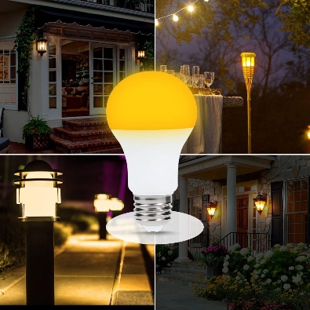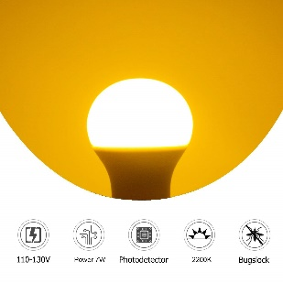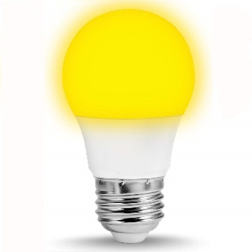

#### Lights Bulb 13.5W Sensor Light Bulbs with photocell, A20 100W Equivelent Automatic Indoor/Outdoor Lighting Lamp for Porch, Hallway(E26/E27, 1200lumen, 6000K) 2 Pack

$97

##### **Technical Details**

Product Code: BA988-KOFF

Brand: MINGER

Item Weight: 12 ounces

Product Dimensions: 2.6 x 2.6 x 5 inches

Assembled Height: 5.04 inches

Assembled Length: 2.56 inches

Assembled Width: 2.56 inches

Style: A20

Color: 13.5w A20 Dusk-to-dawn s[2pack]

Shape: A20

Material: Plastic, Metal

Voltage: 110 volts

Specific Uses: General purpose

Fixture Features: Dusk-to-dawn, A20 Shape, Auto on off, Not Dimmable

Shade Material: Plastic

Batteries Included: No

Batteries Required: No

Luminous Flux: 1200 lm

Wattage: 13.5 watts

Color Temperature: 6000 Kelvin

**Description**

• ☪ AUTO TURN ON/OFF - Built-in light sensors, it will automatically turn on at dusk and off at dawn by detect the light intensity. Turn off > 45Lux, turn on 15Lux. Never waste your time to turn the light on or off physically.

• ☪ ENERGY SAVING - Replace a 100W traditional light bulb with a 13.5W LED bulb. Provide enough brightness as well as save 80% energy, effectively cuts your electricity costs.

• ☪ LONG LIFETIME - MINGER light bulb provides 30,000 hours lifetime, which is made of plastic mask according to the LED chip unique cool requirements. It can solve the hassle of frequent bulb replacement. No glare, no flicker. One year warranty

• ☪ WIDELY APPLICATION - The standard A20 LED bulbs with E26/E27 medium base are suitable for industrial, commercial and residential applications. They are widely used in porches, corridors, garages, courtyards, warehouses, stairs, corners, lofts, outdoors.

• ☪ SAFE & WARRANTY - CE, RoHS compliant. Lead-free, mercury-free, without antimony or other harmful elements, meet the criteria of green lighting. ONE YEAR WARRANTY, you can contact our customer service if you have any problem.

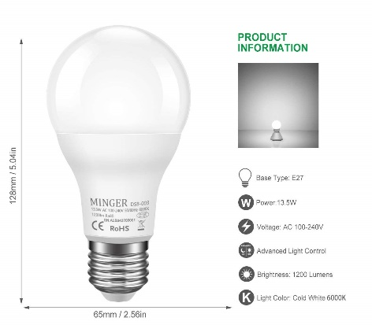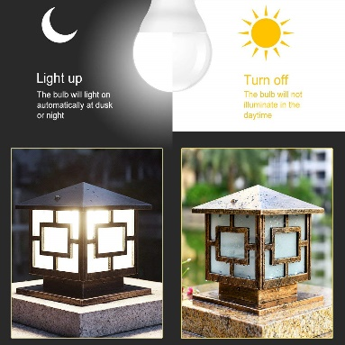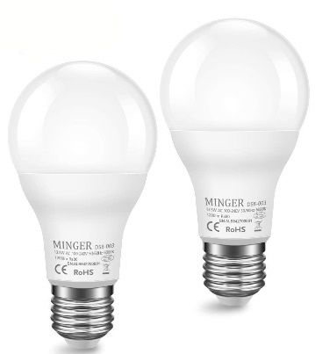

#### Smart Lights

#### Hive LED Light Bulb for Smart Home, Multi-Color, Works with Alexa & Google Home, Requires Hive Hub

$155

##### **Technical Details**

Product code: US817459020400

Item Weight: 4 ounces

Product Dimensions: 1.2 x 1.2 x 4.7 inches

Color: Multi

Style: Multi-Color Bulb

Material: Plastic

Shape: a19

Wattage: 9.5 watts

Item Package Quantity: 1

Type of Bulb: LED

Luminous Flux: 806 lm

Usage: indoor use only

Included Components: Hive Active Light Color-Changing

Batteries Included: No

Batteries Required: No

Warranty Description: 1 year limited manufacturer warranty.

##### **Description**

• You will receive (1) Smart Home LED Light Bulb, Multi-Color

• Create the perfect lighting atmosphere: Choose from 16 million colors

• Save energy: turn your smart lights on or off from anywhere with your phone for easy automation

• Set schedules: turn your smart bulbs on or change their brightness automatically

• Works with Alexa, Google Home and IFTTT

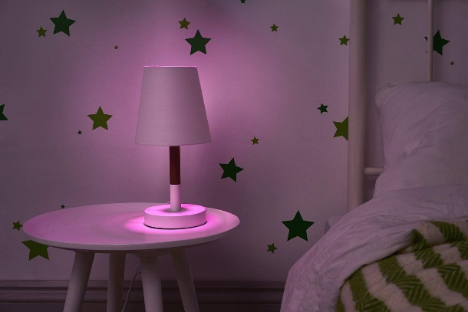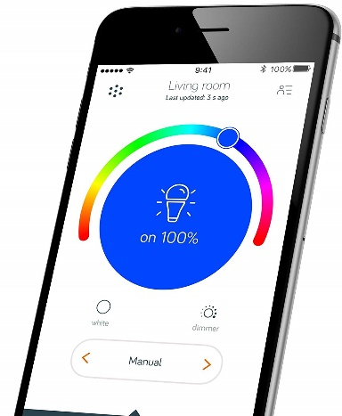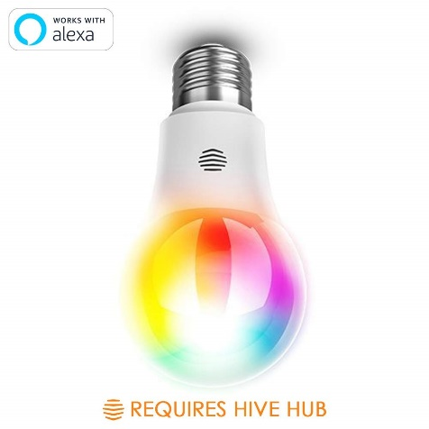

#### Smart Bulb: WiFi Light Bulb - LED Color Changing Light Bulb Dimmable Night Light with Sunrise Mode - Multicolored Smart Bulbs by LUMENTY

$103

##### **Technical Details**

Product code: 859081WF

Brand: Lumenty

Item Weight: 7.2 ounces

Product Dimensions: 2.4 x 2.4 x 4.4 inches

Assembled Height: 4.4 inches

Assembled Length: 2.4 inches

Assembled Width: 2.4 inches

Style: bulb

Collection: Air

Color: Black

Shape: Bulb

Material: Metal

Maximum Compatible Wattage: 7.5 watts

Fixture Features: Light Spectrum Control, Voice control, Create Your Own Sunrise, Music Syncing, Remote Access, Scenes, Schedule, Multi-Device Control, Mood Lighting, Sync Groups of Bulbs, Energy Savings, Control with your voice, App controlled

Batteries Included: No

Batteries Required: No

Type of Bulb: LED

Luminous Flux: 600 lm

Wattage: 7.5 watts

**Description**

• LED LIGHT BULBS THAT YOU'VE BEEN WAITING FOR: Over 16 Million colors and lighting effects in a single bulb. Bright, easy to set up, color wifi bulb no hub required. Control your home lighting with our user-friendly app. With intuitive design, creative features, 24/7 in-app friendly and responsive support, and regular software updates, the Lumenty app is designed to make lighting more fun and unique.

• VOICE CONTROL: Your Lumenty WiFi light works with Amazon Alexa and Google Home. Turn your lights on and off or change their color, all through voice-control (Amazon Echo and Google Dot devices sold separately).

• 100% MONEY BACK PEACE OF MIND GUARANTEE: Since your satisfaction is our top priority, this LED bulb is backed by our 100% money back guarantee and a 2 year limited hardware warranty. Just in case you don’t love this smart LED bulb, return it within 60 days and get your money back. No questions asked.

• SUPER EASY TO SET UP: Control your smart bulb in 3 easy steps. (1) Screw In your Color Smart Bulb, (2) Download the Lumenty App, (3) Connect and Enjoy! No hassle. No weird setups. It’s easy and frustration free.

• SAVE ENERGY – SAVE MONEY: Transform your home and save your hard earned money

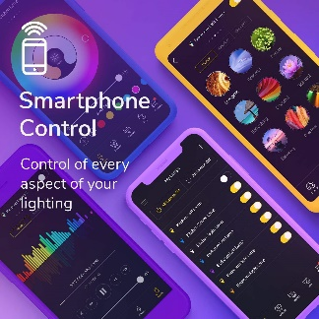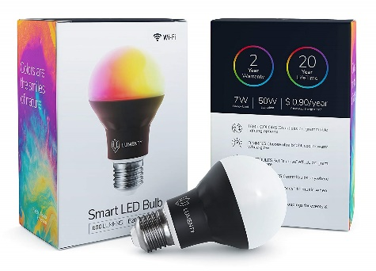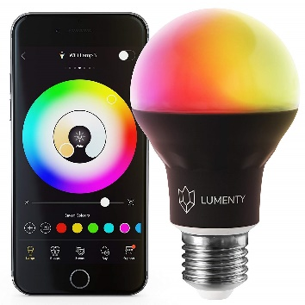

#### Kasa Smart Wi-Fi LED Light Bulb by TP-Link - Soft White, Dimmable, A19, No Hub Required, Works with Alexa and Google Assistant (LB100)

$96

##### **Technical Details**

Product code: LB100

Item Weight: 8.8 ounces

Product Dimensions: 4.1 x 3.1 x 6.7 inches

Item model number: LB100

Size: 50W Equivalent Bulb, White

Color: Soft Warm White

Style: A19,Dimmable

Shape: A19, E26 Fitting

Power Source: AC

Voltage: 120 volts

Wattage: 8 watts

Item Package Quantity: 1

Type of Bulb: LED

Luminous Flux: 600 lm

Special Features: • Control your lights from anywhere with your tablet or smartphone using the free Kasa app (iOS, Android) • Dim brightness to customize lighting and suit your mood • Check on lights remotely and power them off for peace of mind • Control lights individually or in groups by saving your favorite light settings as Scenes • Set schedules, timers, and countdowns and have your lights work around your life • Track real-time and historical energy use to stay informed and save • Use Away Mode to turn lights on and off at different times to give the appearance that someone is home • Compatible Wi-Fi Bands: 802.11n, 2.4GHz Wi-Fi • Lifetime: 22.8 yrs, up to 25,000 hrs

Included Components: Smart Wi-Fi LED Bulb LB100, Quick Installation Guide

Batteries Included: No

Batteries Required: No

Warranty Description: 2 years.

##### **Description**

• Works with Alexa for voice control (Alexa device sold separately).

• CONTROL FROM ANYWHERE - Turn electronics on or off from anywhere with your smartphone using the Kasa app (Compatible w/ Android & iOS)

• VOICE CONTROL - Works with Amazon Alexa, Google Assistant and Microsoft Cortana supported devices for a hands-free experience

• DIMMABLE - Dim brightness to customize Lighting and suit your mood. The LB100 has 600 lumens brightness and dimmable white light

• KASA SCENES & SCHEDULES - Schedule the Smart Bulb to automatically turn on and off when away

• NOTE: Requires a secured 2.4 GHz Wi-Fi network connection

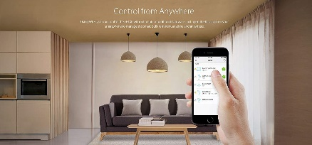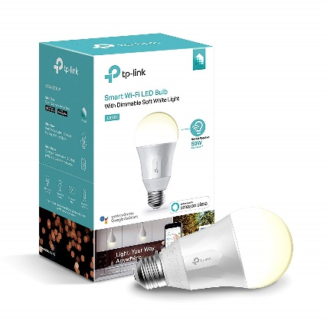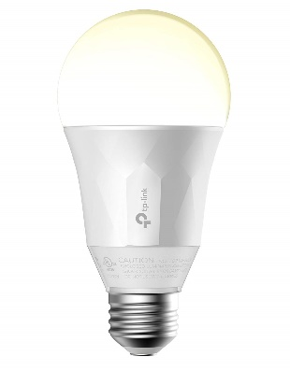

#### Philips Hue Bridge 2.0

$69.99

##### **Technical Details**

Type Smart : LED Light Fixture

Product code: 57UKI-0988

Device Compatibility : HUE Family of Products; IFTTT; Works With Nest; HomeKit

HomeKit : Yes

Works with Nest: Yes

Connectivity: Zigbee

Operating environment: Indoor

RF range: 30 m

Wi-Fi: Yes

Bluetooth: No

HomeKit-enabled: Yes

Auto-Shut Off: No

Motion Activated: No

Colour Changing: No

Built In Speaker: No

Energy Monitoring: No

2-Wire Installation: No

Remote Control Included: No

Smart Light Bulb: No

Smart Light Control: Yes

Wifi Compatibility: Zigbee Light link protocol 1.0 certified; Frequency band 2400 - 2483.5 MHz

Voltage: 100 - 240V AC

Standby power consumption: 1.5 W

Works with Google Assistant: Yes

##### **Description**

• The brain of your system: The bridge is a key component of your Philips Hue smart lighting system, as it lets you control your Philips Hue lights using the Philips Hue app on your smartphone.

• Compatible with Apple HomeKit: The Philips Hue Bridge 2.0 works with Apple HomeKit, enabling convenient voice control via Siri and allowing you to connect to other HomeKit-compatible devices so you can get the most out of your smart home.

• Peace of mind: All Apple HomeKit data is end-to-end encrypted, so you can rest assured knowing that the only people who can control your smart home system are the members of your household.

• Convenient compatibility: If you're upgrading your old bridge to the Hue Bridge 2.0, all your existing Philips Hue lights and switches will work with the new model and can be controlled via Apple HomeKit.

• Easily expandable: With the Philips Hue Bridge 2.0, you can add up to 50 Philip

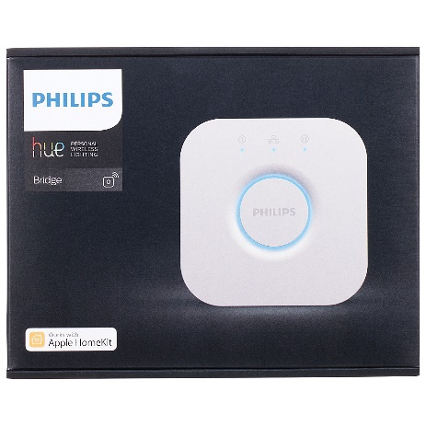

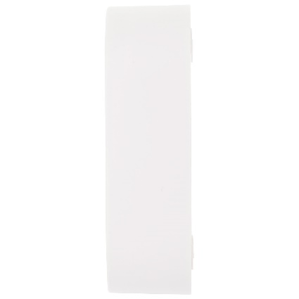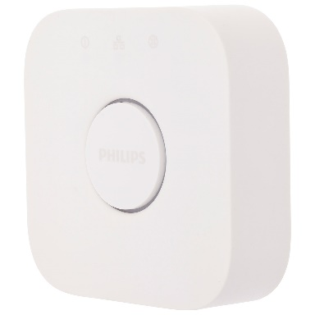

#### Philips Hue White Ambiance A19 Wi-Fi Smart Light Bulb - 2-Pack

$111

##### **Technical Details**

Brand: Philips

Product code: 461020

Item Weight: 6.4 ounces

Product Dimensions: 2.5 x 2.5 x 4 inches

Size: 2 Bulb

Color: White

Style: Standard

Shape: a19

Voltage: 120 volts

Wattage: 10.5 watts

Item Package Quantity: 1

Type of Bulb: LED

Luminous Flux: 800 lm

Certification: certified frustration-free

Special Features: Dimmable

Included Components: Hue white ambiance A19 LED bulb

Batteries Included: No

Batteries Required: No

Warranty Description: 2 years

##### **Description**

• With wireless control on your smartphone or tablet, choose the perfect light setting for any mood or activity such as reading or relaxing, concentrating, or energizing

• Requiring the Hue Bridge (sold separately) for the full Hue experience, this bulb fits standard-size table lamps

• Install the LED light as you would install ordinary bulbs, pairing them with the Hue Bridge, which allows you to control smart-bulb-equipped lamps and overhead lights via the Philips Hue App

• Easily expand your lighting system with accessories (sold separately), such as a Hue Dimmer Switch, Hue Tap, or Hue Motion Sensor

• This box includes one Philips Hue white A19 standard light bulb, manual, and two-year warranty

• Pair it for automation with your existing Nest or SmartThings system

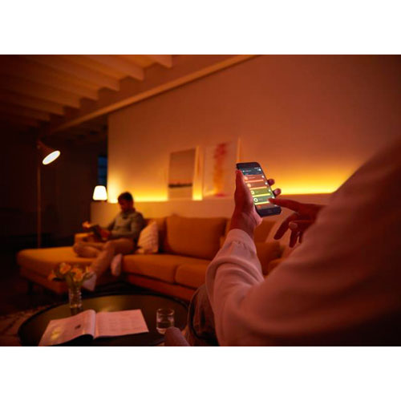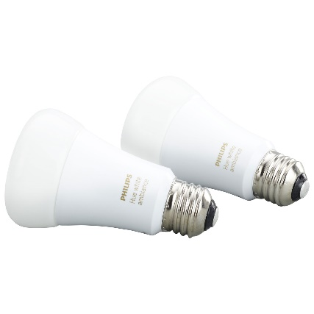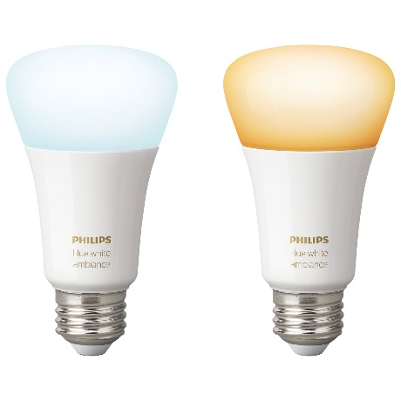

#### Philips Hue Chandelier White & Colour Smart Wi-Fi Light Bulb

$59.99

##### **Technical Details**

Product code: 468900

Item Weight: 2.08 ounces

Product Dimensions: 1.5 x 1.5 x 4.6 inches

Size: 1 Bulb

Color: White & Color Ambiance

Style: White and Color Ambiance

Material: Glass

Shape: Candle

Voltage: 120 volts

Wattage: 6.5 watts

Item Package Quantity: 1

Type of Bulb: LED

Luminous Flux: 450 lm

Included Components: This box includes one Philips Hue color E12 candelabra light bulb, manual, and two-year warranty.

Batteries Included: No

Batteries Required: No

Warranty Description: 3 year warranty.

##### **Description**

• VOICE CONTROL: The Philips Hue White and Color Ambiance Smart Bulb Candle works with Alexa for voice control (Philips Hue Hub required, Alexa smart device and hue hub sold separately)

• SCHEDULE YOUR OWN CUSTOM LIGHTING SCENES: With wireless control on your smartphone or tablet, choose the perfect smart light setting for any mood or activity such as reading or relaxing, concentrating, or energizing. This is the perfect way to personalize your smart home

• MAXIMUM FLEXIBILITY: Requiring the Philips Hue Hub (sold separately) for the full hue smart lighting experience, this E12 LED smart light is designed to fit candelabra lamps in nightlights, chandeliers, and more

• EASY INSTALLATIN: Install the smart light as you would install an ordinary bulb, pairing it with the Philips Hue Hub. Install your Philips Hue White and Color Ambiance Candle easily into your smart home

• EXPAND YOUR ECOSYSTEM: Easily expand your smart lighting system with Hue accessories (sold separately), such as a Hue Dimmer Switch, Hue Tap, or Hue Motion Sensor. Pair it for home automation with your existing smart home devices like Nest or SmartThings system

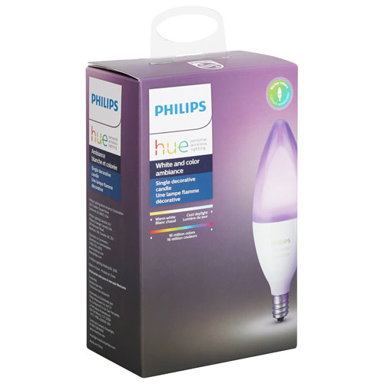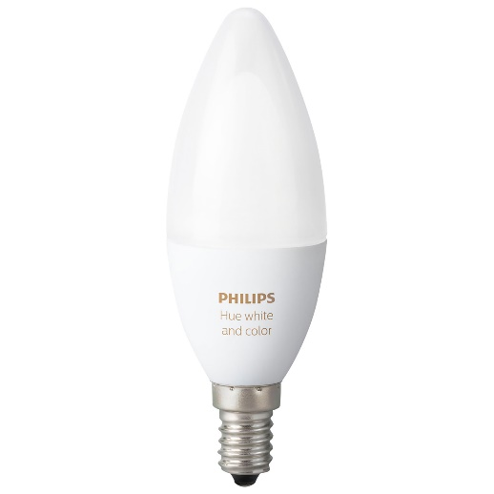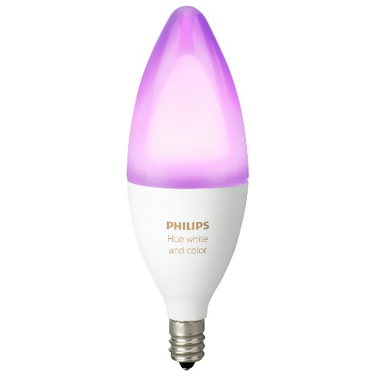

#### Philips Hue White Ambiance Cher Flush Smart LED Light

$200

##### **Technical Details**

Product code: 4096730U7

Item Weight: 6.65 pounds

Product Dimensions: 18.7 x 18.7 x 3.7 inches

Color: Black

Style: Flush Smart

Shape: Circular

Voltage: 120 volts

Wattage: 39 watts

Item Package Quantity: 1

Special Features: 50,000 Shades of White, Instant On, Dimmable

Included Components: Philips Hue White Ambiance Cher Flushmount Light

Batteries Required: No

Warranty Description: 2 years.

##### **Description**

• With wireless control on your smartphone or tablet, choose the perfect light setting for any mood or activity such as reading or relaxing, concentrating, or energizing

• Requiring the hue hub (sold separately) for the full hue experience, this sleek light creates ambiance with warm white to cool white light

• Install it anywhere you would a standard overhead light and pair it with the hue Hub, which allows you to control this and other Philips hue lights via the Philips hue app

• Easily expand your Lighting system with accessories (sold separately), such as a hue dimmer switch, hue tap, or hue motion sensor. Pair it for automation with your existing Nest or SmartThings system

• This box includes one Philips hue white ambiance cher Flushmount light with manual and two-year warranty.Total lumen output fixture:3000 lm

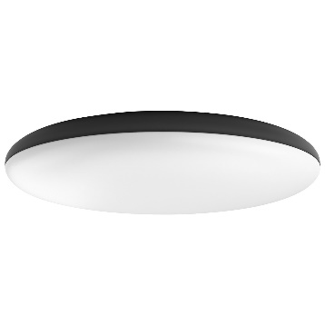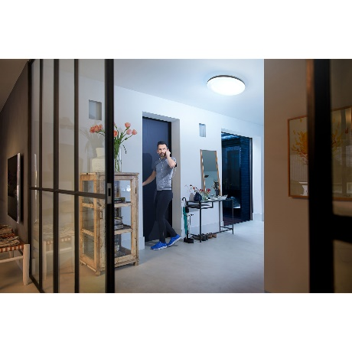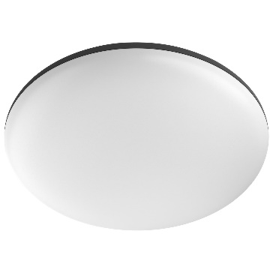

#### LIFX A19 Smart LED Light Bulb - Multi-Colour

$59.99

##### **Technical Details**

Product code: LHA19E26UC10

Item Weight: 7.8 ounces

Product Dimensions: 2.5 x 2.5 x 4.5 inches

California residents: Click here for Proposition 65 warning

Size: Single

Color: Multi

Style: A19

Material: Glass

Shape: A19

Voltage : 240 volts

Wattage: 11 watts

Item Package Quantity: 1

Type of Bulb: LED

Luminous Flux: 1100 lm

Special Features: Works with Alexa, Apple HomeKit and the Google Assistant

Included Components: LIFX (A19) Wi-Fi Smart LED Light Bulb, Adjustable, Multicolor, Dimmable, No Hub Required

Batteries Included: No

Batteries Required: No

Warranty Description: 2 year warranty.

##### **Description**

• Works with Amazon Alexa to support dimming, shades of white, and color settings through voice control (Alexa device sold separately)

• 16 million colors and warm to cool whites. LED life-span - 22.8 years (based on 3hrs/day)

• Easy to set up, built in wifi - no hub required

• Bright - equivalent to 75W bulb. Beam Angle: 135 degrees

• Works with Alexa, Apple HomeKit and Google Assistant

• Note: Kindly refer attached manual for guidance on installatio

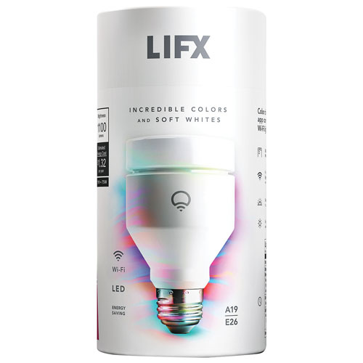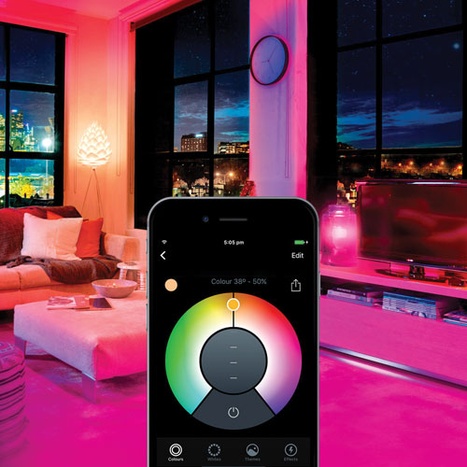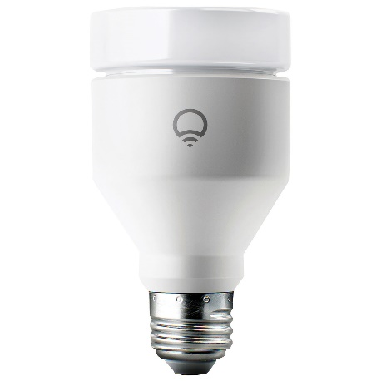

#### Hue White and color ambiance Beyond table lamp

$199.99

##### **Technical Details**

Brand: Philips

Product code: 798082

Height: 40.4 Centimeters

Length: 40.4 Centimeters

Width: 29 Centimeters

Weight: 3.86 Kilograms

Style: Beyond Table Lamp

Colour: White

Material: Synthetics

Number of Lights: 2

Included Components: 1 Hue Gen 2.0 Beyond Table Lamp

Specific Uses: Indoor use only

Power and Plug Description: Electric

Batteries Included: No

Batteries Required: No

Type of Bulb: LED

Wattage: 9

Wattage: 4.5 Watts

Colour Rendering Index (CRI): 80

##### **Description**

• Philips Hue beyond table lamp includes an up light and down light for functional lighting and an endless mix of colors

• Gives you total control over your lighting from your smart phone or tablet - even when you're away from home

• Through your smart device, set timers and alarms, connect to a variety of apps and dim the light (cannot be used with conventional dimmers)

• Control up to 50 Hue products on a single Philips Hue bridge (compatible with zigbee certified and wink network products)

• Single pack includes one Hue beyond table lamp - requires a Hue starter kit or compatible bridge for dimming and smart control

• Lumens: 600lm at 4000K, 510lm at 3000K, 360lm at 2000K, 505lm at 6500K

• Warranty: 2 year on product

• All Hue products require a Hue Bridge (Gen 1 or Gen 2) to function. Hue bulbs, Hue Light strips, Hue Go, Hue Bloom, and all other Hue luminaires can be paired with Echo Dot, Echo, and Echo Tap only when used with Hue Gen 2 bridge (Gen 1 Bridge is not compatible)

• All Hue products can connect directly to Echo Plus (without a Hue Bridge) though they will still need a Hue Bridge (Gen 1 or Gen 2) to be controlled via the Philips Hue App

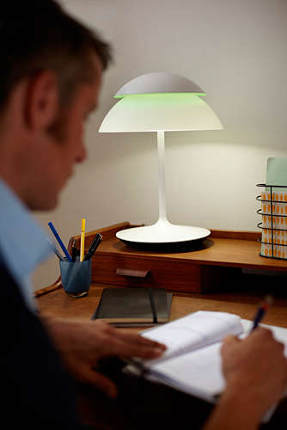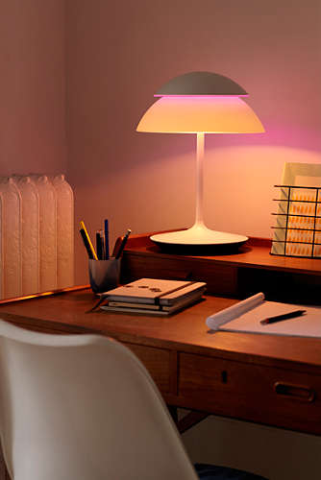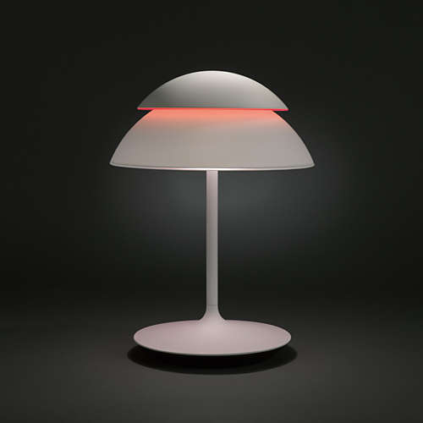

**Decoration Lights**

#### Quace Plastic 138 LED Curtain String Lights with 8 Flashing Modes Decoration

$45

##### **Technical Details**

Brand: Quace

Product code: 7613-3411

Height 8.4 Centimeters

Length 25 Millimeters

Width 19.1 Centimeters

Assembled Depth 3.30 Inches

Weight 449 Grams

Colour Warm White

Material Plastic

Batteries Included: No

Batteries Required: No

##### **Description**

• 8 Mode settings: combination, in waves, sequential, slo glo, chasing/flash, slow fade, twinkle/flash and steady on

• 6.7ft3.3ft star curtain string lights with 138 LEDs, 12 stars ornaments (6 big and 6 small), the large star ornaments diameter is 0.67ft, which each string droops 3.3ft

• Small star diameter is 0.3ft, which each string droops 2ft. Power line length is 3.3ft

• Easy to use, directly plug in and unplug it for power on and off. UL Certificated Output and wire: 29V Voltage Safe Curtain Lights with UL certified, leads to 29V safe output by UL plug-in transformer

• Safe, power-saving and eco-friendly. High-brightness string light, but not dazzling. Waterproof level is IP44, but the power and controller is non-waterproof, please keep them away from water Perfect for indoor and outdoor decorations. Christmas, Valentine's Day, party, wedding, home, festival, holiday, restaurant, hotel, commercial building, shopping center and more

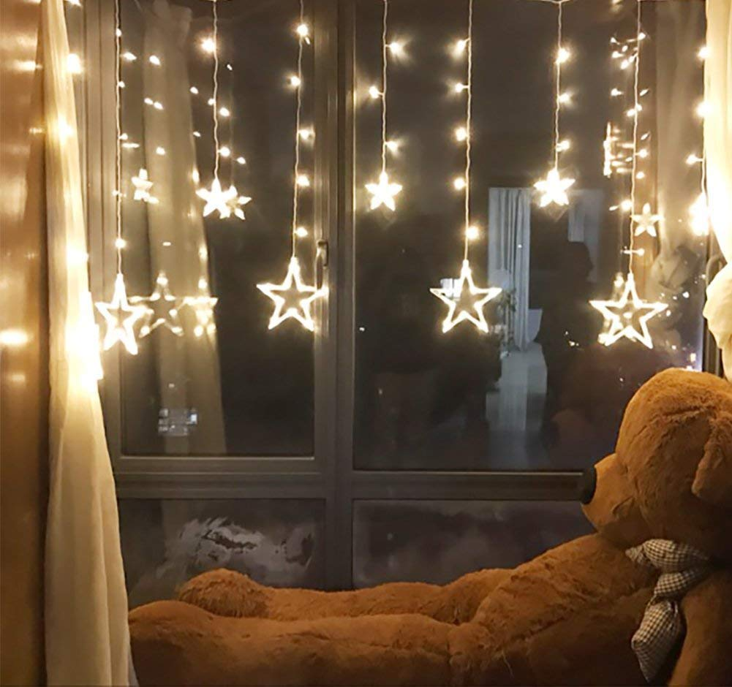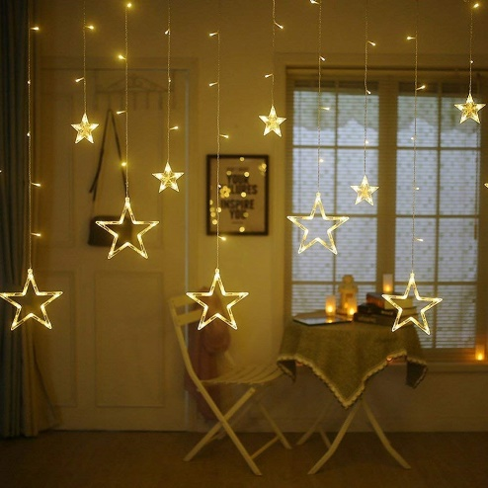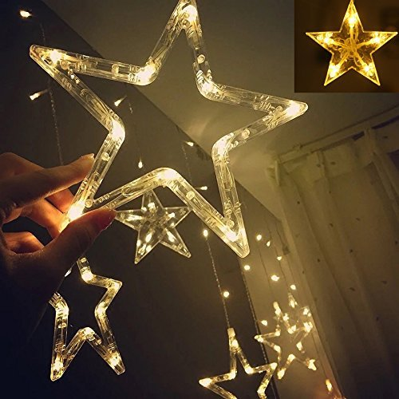

#### AtneP 20 LED Rose String Lights for Decoration (Warm White)

$82.50

##### **Technical Details**

Brand: AtneP

Product code: 1WKI-3451

Colour: Warm White

Material: Others

Batteries Included: No

Batteries Required: No

##### **Description**

• Shape rose - rose colour white

• Led colour: warm white (Yellow)

• Number of leds 20 - 4 meter long

• Ac power supply | the flowers are soft design but sturdy, micro led is super bright with holiday atmosphere

• The rose string lights are very safe and don't get hot and you can use them almost anywhe

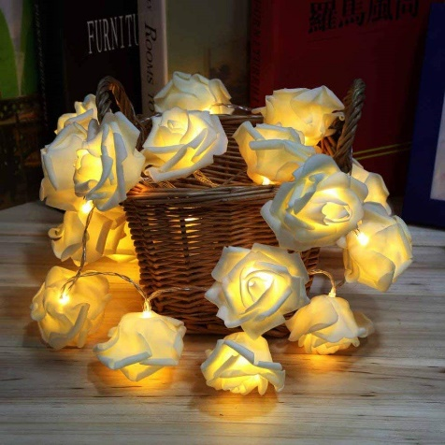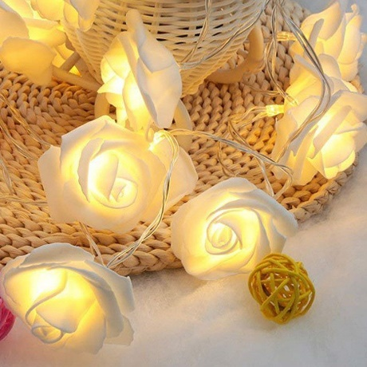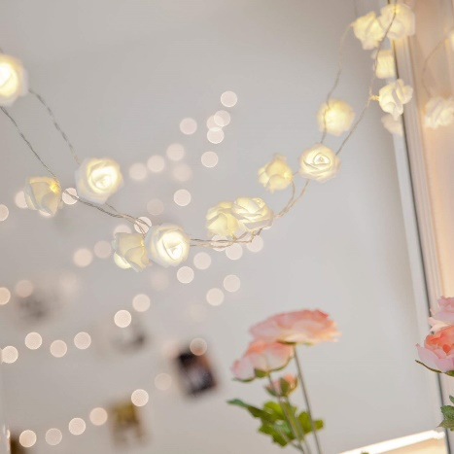

#### Citra String Light 33 ft 38 LED Crystal Ball Outdoor String Lights Fairy Lights for Garden Home Decorations (Multi Color Crystal Ball)

$65

##### **Technical Details**

Brand: CITRA

Product code: BALL-7133

Colour: multi colour

Material: Copper

Batteries Included: No

Batteries Required: No

##### **Description**

• WATER-RESISTANT & CONSTANT LIGHTING: IP44 waterproof grade is suitable for outdoor environment to withstand light rain or water spills

• QUALITY ASSURANCE: Crystal ball protects LED and makes the light shell strong and high lighting performance. Comprehensive protection with CE certification provides a safe using environment for anyone.

• There are 38 led crystal balls with a total wire length of 10 Metres With ONLY FLASHING MODE

• The String Light Can be connected directly to a power outlet as it includes a Indian 2 Pin Plug

• The Wire Is black In Colour With Only Flashing/Strobe Mode

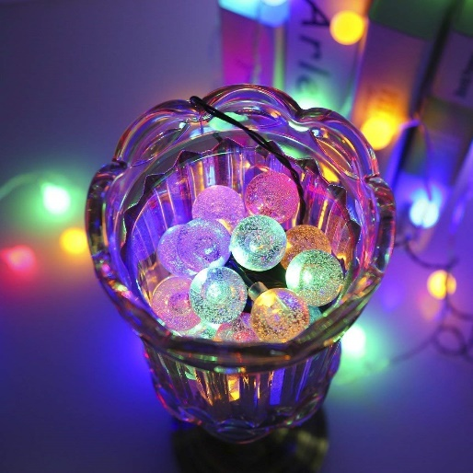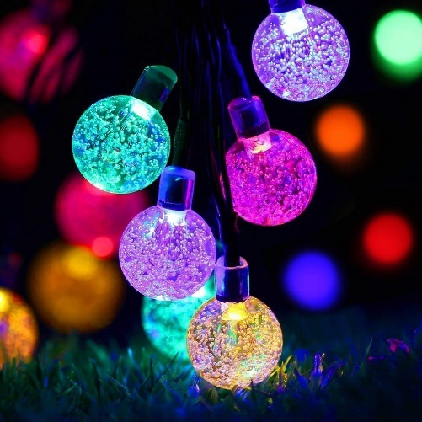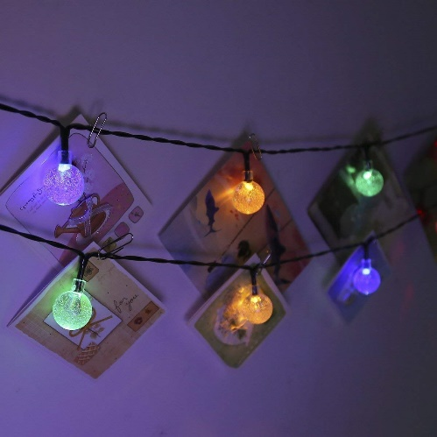

#### LEDMOMO Cotton Ball String Lights - 20 LED 9.8 ft Battery Powered Globe Fairy Light for Christmas Wedding Party Decoration

$89

##### **Technical Details**

Color: As shown.

Product code: 9881-0999

Material: Plastic and cotton.

Size: Approx. 330 x 6 x 6 cm / 129.9 x 2.4 x 2.4 inch (L x W x H).

Power: 3W

Waterproof: IP20

Made of high quality material, the string lights are durable and long lasting use.

The string light can be hung on tree branches, bushes, roof, eave, fence or any other places you want.

Suitable for All Occasions. This wonderful string lights illuminate during night, adding warm and charming atmosphere to your garden, patio, lawn, porch, gate, fence, yard. Perfect for Christmas and holiday party decoration.

Adding a warm and charming festive atmosphere to your gatherings.

Easy to use and install.

Package Including

1 x Plastic and Cotton Ball String Lights Globe Fairy Light Battery Powered 3M 20 LED Light for Indoor Outdoor Party Weedings Christmas Decoration

##### **Description**

• Made of high quality material, the string lights are durable and long lasting use.

• The string light can be hung on tree branches, bushes, roof, eave, fence or any other places you want.

• Suitable for All Occasions. This wonderful string lights illuminate during night, adding warm and charming atmosphere to your garden, patio, lawn, porch, gate, fence, yard. Perfect for Christmas and holiday party decoration.

• Adding a warm and charming festive atmosphere to your gatherings.

• Easy to use and install.

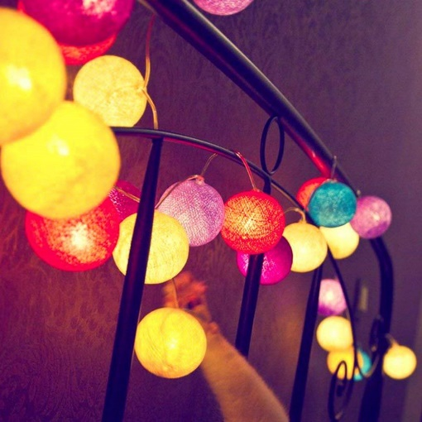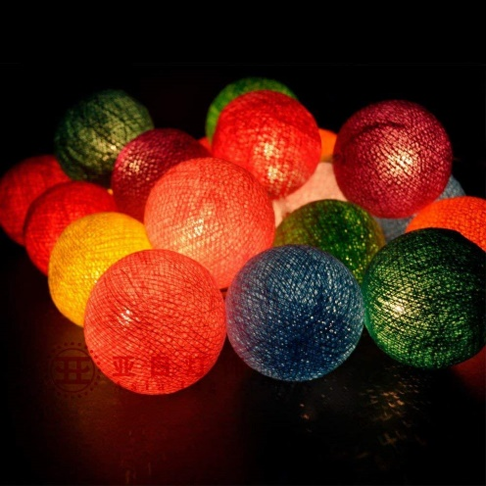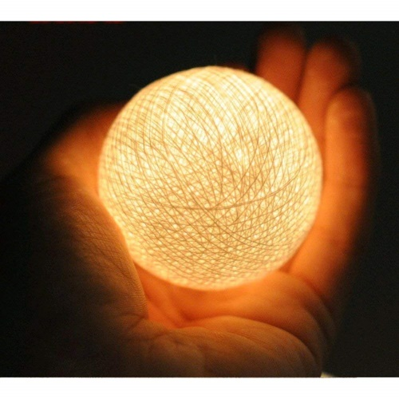

#### AtneP Tree Home Decoration 24 LED Lighting | Size 14 x 5" Inch | Festival Lamp Creative Gift Diwali Christmas Wedding Party Event - Multi Color

$55

##### **Technical Details**

Brand: AtneP

Product Code: BA19-04754

Colour: Multi

Material: Metal

Batteries Included: No

Batteries Required: No

##### **Description**

Christmas Tree Home Decoration Lighting | Size 14 x 5" Inch | Festival Lamp Creative Gift Diwali Christmas Wedding Party Event - Multi Color. AtneP brings a wide range of decorative lights hanging, collection which includes Rice Lights, String Lights, Fairy Lights, Lights for Decorations, Decorative lights for wall items by AtneP. Decoration lights have varieties of shapes and colors which also comes in plastic and metal. Search for "AtneP Lights" on Amazon to find more varieties of Lights for Home Decor, Festive Decoration Diwali Christmas New Year, Party Event or Wedding Decoration, We have all type of Lights in our shop to decor your Home Garden, Bedroom, Living Room, Balcony.

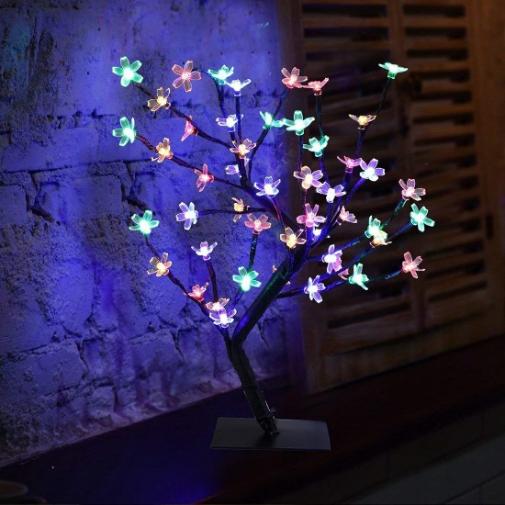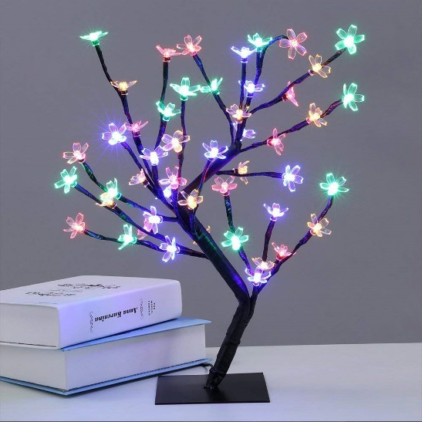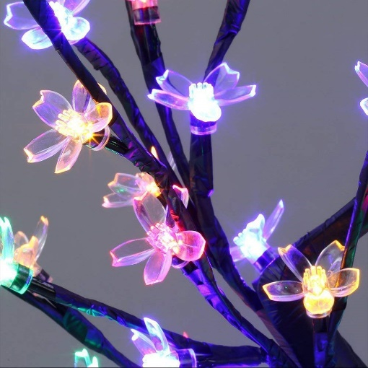

#### Solar Lantern Lights Outdoor,Garden Hanging Lights Metal Leaf Pattern Lights Lamp for Patio,Outside or Table (Leaf.)

$32

##### **Technical Details**

Brand: Take Me

Product code: ATM1819-NewLeaf

Item Weight: 10.6 ounces

Package Dimensions: 9.4 x 6 x 5.9 inches

Batteries: 1 AA batteries required. (included)

Style: Art Deco

Color: Leaf.

Material: Metal

Number of Lights: 1

Included Components: Batteries included

Voltage: 2 volts

Specific Uses: Outdoor use only

Shade Material: Metal

Power Source: solar

Batteries Included: Yes

Batteries Required: Yes

Type of Bulb: LED

##### **Description**

• SOLAR POWER :Solar Panel collects sunlight to charge the batteries(included) during the day; Automatically turns on at dusk for up to 8 hours of nighttime illumination;

• 7 Lumens Warm White Lantern: Easily add ambiance to your garden,Table or patio with TAKEME outdoor solar lantern. Action morpho us shadow: delicate leaf reflection after lighting up, giving you unexpected visual effect.

• Durable, eco-friendly and reliable: no power cord required, no electricity cost, no conventional energy consumption; waterproof, corrosion resistant and can work outdoors in rainy days.

• Size: 4.9”(L)*4.9”(W)*7.87”(H).Perfect for decoration for garden, table, balcony or outdoor. A best gift for your friend.

• Make sure the button is in the “ON” position before change it in the sun.If the button is in “on” position, keeping the solar panel in the darkness, then the lights will light up.100% LIFETI REPLACEMENT GUARANTEE! Simply contact us if you ever have issues with your TAKE ME lights

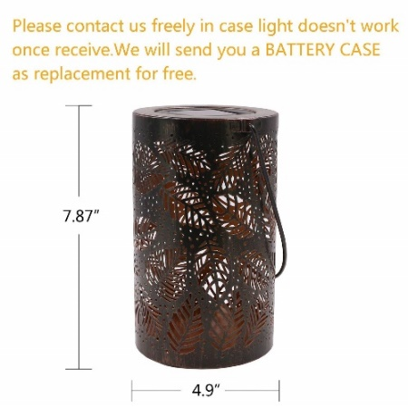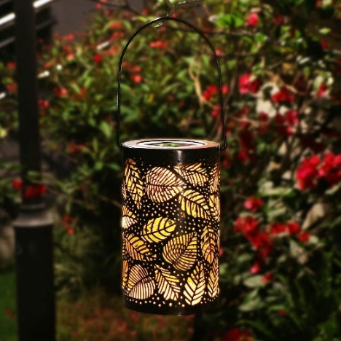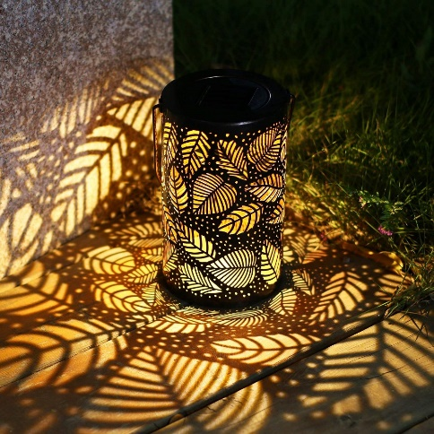

#### Light Bulb with Upside Down Effect, Flickering Flames Table Lamp LED for Holiday Decoration/Hotel/ Bars/Home/ Restaurants

$130

##### **Technical Details**

Product code: 8998IOP

Product Dimensions: 2.8 x 2.8 x 5.5 inches

Item Weight: 8.6 ounces

Shipping Weight: 11.2 ounces (View shipping rates and policies)

Manufacturer: GELOO

ASIN: B07G2H8HGP

##### **Description**

• 【Flickering Flame Design】The distinctive dancing flame is attractive, which looks like the real flame; This decorative lamp with warm flame colors decorate your space and give you a quiet, romantic and relaxing moment

• 【Rechargeable Battery Powered】 No more worrying about replacing batteries. Built-in 2000mAh rechargeable battery lasts for up to 18 hours after being fully charged. Place your dancing flame light anywhere you want without the need for any cables

• 【Waterproof & Magnetic Base】Stick the primitive burning decor to any metallic surface with the built-in magnetic base. IP44 Waterproof capability makes the dancing flame lamp perfect for outdoor activities like by the pool, hiking, lawn, porch, etc.

• 【100% Safety】CE, RoHS, FCC, UL Certification, made of energy-saving and environmentally friendly materials, low-voltage DC charging. No harmful substances.

• 【Usage Recommendation】You can use it indoor or outdoor, like the desk light, floor lig

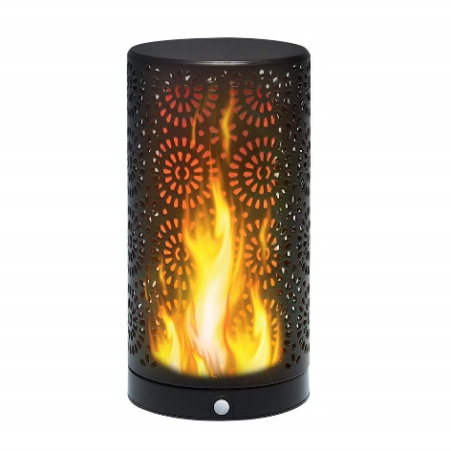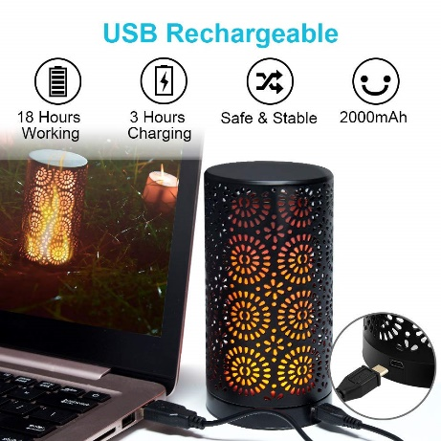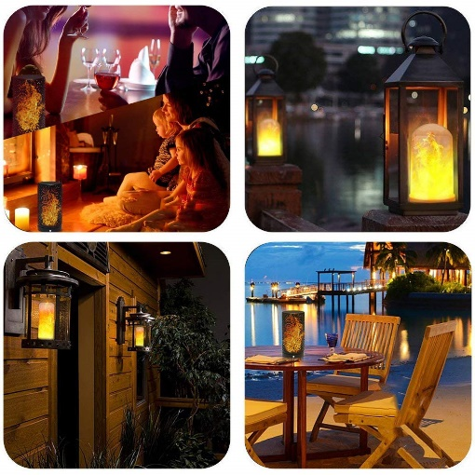

#### AmazonBasics Patio Lights, White, 50'

$80

##### **Technical Details**

Product code: PL100-50-WHT

Item Weight: 2.33 pounds

Product Dimensions: 17.2 x 8.6 x 3.7 inches

California residents: Click here for Proposition 65 warning

Item model number: PL100-50-WHT

Size: 50 Feet

Color: White

Style: G40 Bulb

Shape: G40

Item Package Quantity: 1

Type of Bulb: Incandescent

Certification: certified frustration-free

Batteries Required: No

##### **Description**

• 50-foot patio string of lights with 50 clear incandescent G40 globe bulbs; ideal for decks, yards, outdoor venues, and indoor decor

• End-to-end connectable design; male plug with 6-inch lead to first bulb and female connector with 6-inch lead to last bulb

• UL listed; rated for 960 total watts; safely connect up to 3 50-foot strands for a total of 150 feet of continuous lighting (each string sold separately)

• 12-inch spacing between each bulb; 5-watt G40 globe bulb casts a warm glow; E12 candelabra base, 120V

• White string color; backed by an AmazonBasics one-year limited warranty

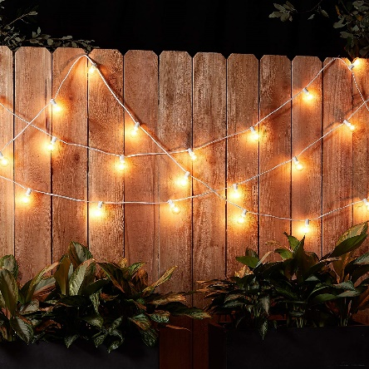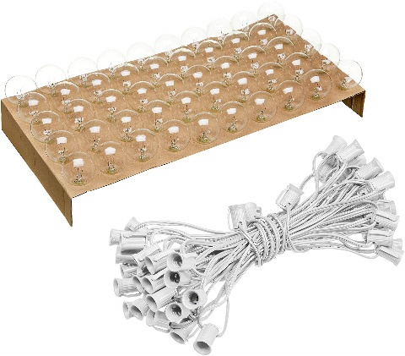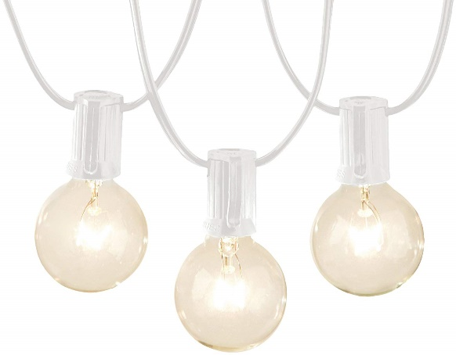

#### LAKES LED Flame Bulb, 1300K True Fire Color, Pack of 1 Unit

$147

##### **Technical Details**

Product code: LAKES-FL-1300K

Item Weight: 6.4 ounces

Product Dimensions: 5.1 x 2.1 x 2.1 inches

Size: 1-Pack

Color: Flame Bulb

Style: Single Mode

Material: Plastic

Shape: Tubular

Power Source: AC

Voltage: 120 volts

Wattage: 3 watts

Item Package Quantity: 1

Type of Bulb: LED

Luminous Flux: 150 lm

Special Features: flame

Batteries Included: No

Batteries Required: No

##### **Description**

• ✔ SPECIAL SINGLE MODE: Like moving flaming fire torch from the bulb base to the top

• ✔ USAGE RECOMMENDATION: To get better flame flickering performance like true fire, install this bulb in a frosted lampshade, frosted lantern, etc.

• ✔ TRUE FIRE COLOR & EASY TO CONTROL: Exact 1300K color is close to true fire color, not like so called warm white(2000K-3000K);

• ✔ APPLICATION: Church, castle, monastery, bedroom, living room, bar, hotel, night clubs, outdoor gardens, villas, wedding decorations, party

• ✔ HASSLE-FREE WARRANTY: 1 year warranty, 50000 hours lifespan, 30 days money back guarantee, E26 Base compatible, AC100V-245V, 50/60Hz.

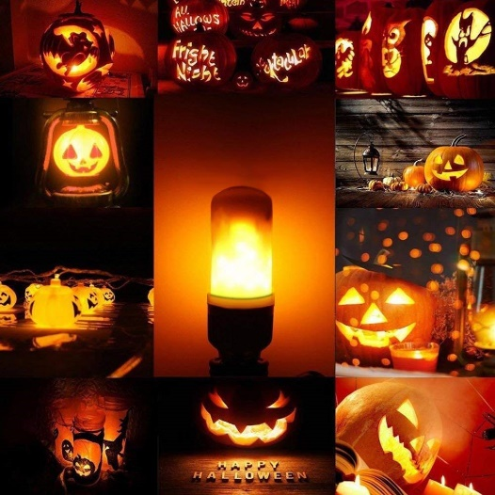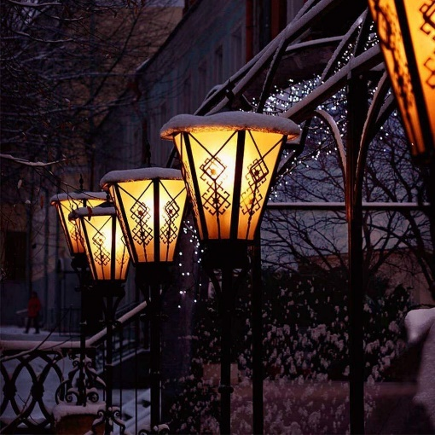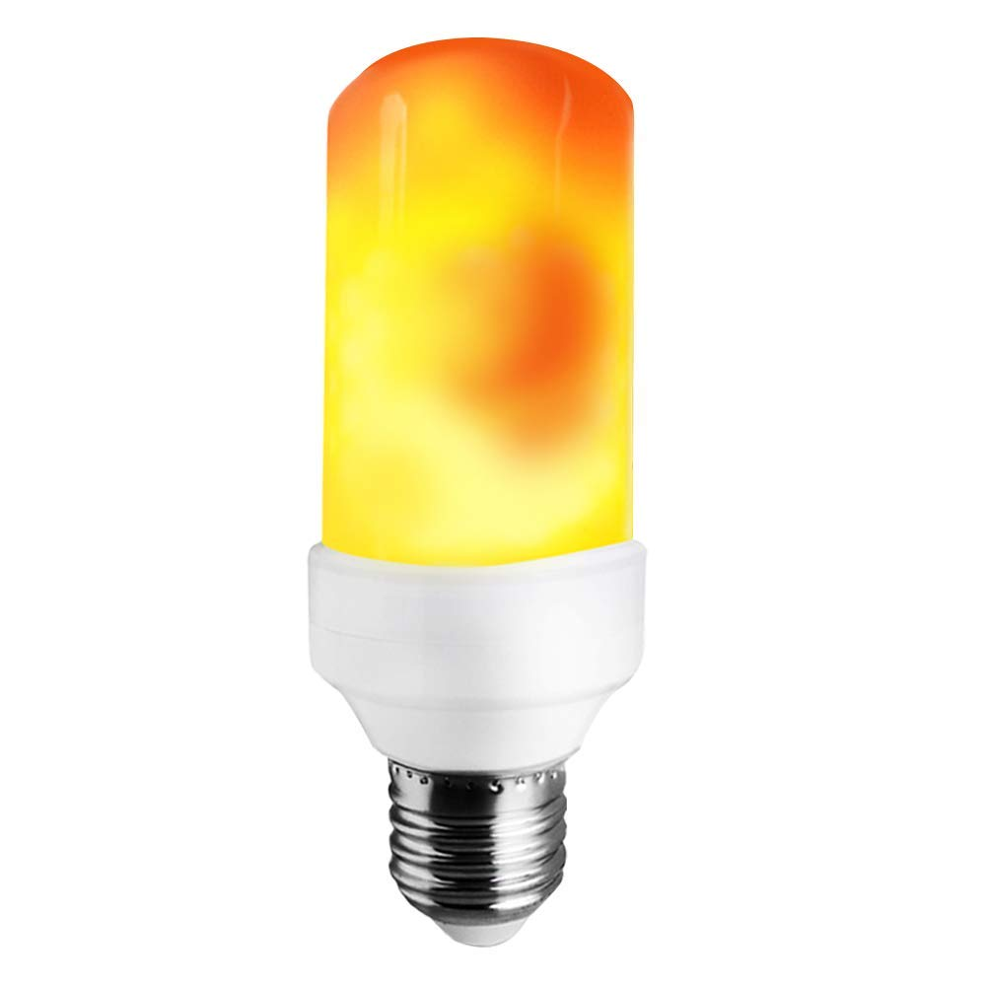

**Spot Lights**

#### VOLT® Forged Brass Underwater Light

$49.97

##### **Technical Details**

Product Code: 8A19-04MF

Materials

Construction: Cast brass

Finish: Antique bronze

Lead Wire: 25' 3x 18AWG, SPT-1 premium tinned copper wire

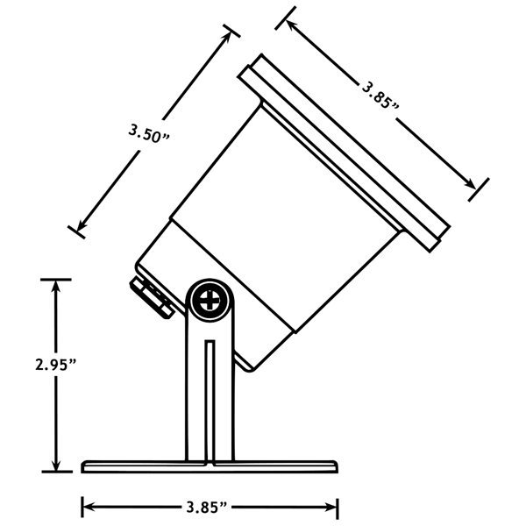 Lens: Clear flat glass

Dimensions: Entire Fixture: 6.45" x 3.85" Base: 3.85"

Photometrics

Light Source: LED or halogen MR-16 (sold separately)

Light Output: (Lumens) See specs for MR-16 lamps

Beam Angle: See specs for MR-16 lamps

Color Temperature: (CCT) See specs for MR-16 lamps

Color Rendering: Index (CRI) See specs for MR-16 lamps

Lamp Life: (L70) See specs for MR-16 lamps

Certifications

UL & cUL Listed

WarrantyLifetime

Electrical

Energy Consumption: (watts) See specs for MR-16 lamps

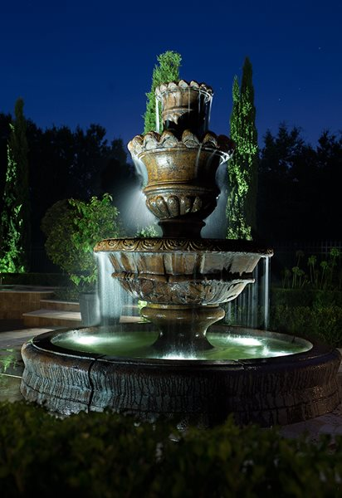 Power Factor: See specs for MR-16 lamps

Operating Voltage: RangeSee specs for MR-16 lamps

Power Supply: VOLT® Low Voltage Transformer (sold separately)

Installation

Orientation Directed upwards only, Underwater applications only.

##### **Description**

• Solid forged brass construction

• Antique bronze finish

• Uses MR16 Lamp (Not Included)

• 25' 18AWG, FT2 premium tinned copper lead wire

• Beryllium socket with conductive grease

• Water tight seals --- pressure rubber gasket, rubber seal around wire exit. (fully submersible)

• Clear flat glass for maximum light output

• Silicone plug where lead wire exits fixture

• Perfect for placing in fountains, waterfalls, water gardens, ponds, etc.

• Note: Fixture must be fully submerged at all times of operation

• Low voltage, 12v AC for safe installation

• Requires VOLT's® Low Voltage Transformer

• UL & cUL Listed

• Lifetime Warranty

#### VOLT® Fat Boy Solid Copper Spotlight

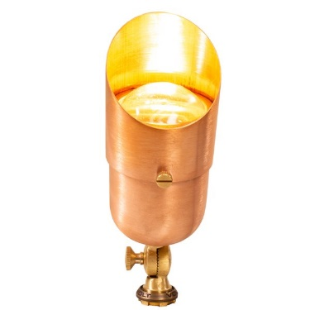$187

##### **Technical Details**

Product code : 981434

Materials

Construction: Copper

Finish: Natural copper

Lead Wire: 4' or 25' UL certified 18AWG, SPT-1 premium tinned copper wire

LensClear: flat glass

Mounting: Include 10" Hammer™ stake with cutout for wire exit

DimensionsEntire Fixture: 8.1" x 3" Shroud 6" x 3" Body: 7.5" x 3" Stake: 10" x 3"

Photometrics

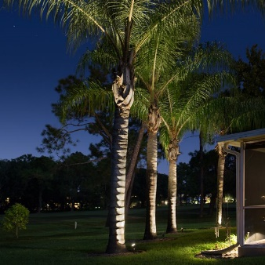 Light Source: LED or halogen MR-16 (sold seperatly)

Light Output: (Lumens)See specs for MR-16 lamps

Beam Angle: See specs for MR-16 lamps

Color Temperature: (CCT)See specs for MR-16 lamps

Color Rendering: Index (CRI)See specs for MR-16 lamps

Lamp Life: (L70)See specs for MR-16 lamps

Certifications

CertificationsUL & cUL Listed

Warranty Lifetime

Electrical

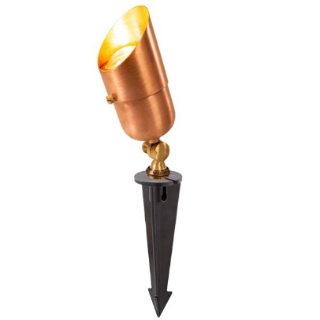 Energy Consumption:(watts)See specs for MR-16 lamps

Power Factor: See specs for MR-16 lamps

Operating Voltage: RangeSee specs for MR-16 lamps

Power Supply: VOLT® Low Voltage Transformer (sold separately)

Installation

Orientation Directed upwards only

##### **Description**

• Copper construction for durability

• Ages beautifully as it patinas throughout the years

• The body is machine threaded and screws tight onto an O-ring for the ultimate moisture tight design.

• 360º rotatable glare guard

• Choose from 4' standard or 25' hub ready 16G, SPT-2 premium tinned copper lead wire.

• The lens is convex so water does not puddle on the lens which reduces hard water build-up and water intrusion.

• Silicone plug where lead wires exit fixture. Prevents ground moisture and insects from entering fixture through the stem.

• Safe low voltage, 12 volts.

• UL & cUL Listed

• Lifetime Warranty.

Orientation Note: Use only for up-lighting. For downward-facing applications, please use VOLT downlights.

#### Infiniti™ 60 G4 Single Source LED Spotlight, Cast Brass

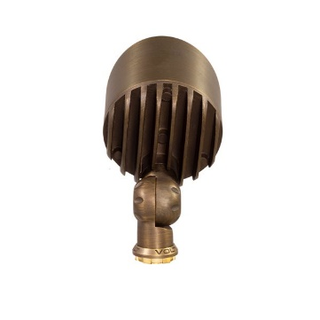$69.97

##### **Technical Details**

Product code: 9EKIK-0888

Materials

Construction: Cast brass

Finish: Antique bronze

Lead Wire: 4' or 25' UL certified 18AWG, SPT-2 premium tinned copper wire

Lens: Clear flat glass

Mounting: Includes 10" Hammer™ stake with cutout for wire exit

Dimensions: Entire Fixture: 5.25" x 2.25" Shroud 3" x 2.25" Body: 4.75" x 2.25" Stake: 10" x 3"

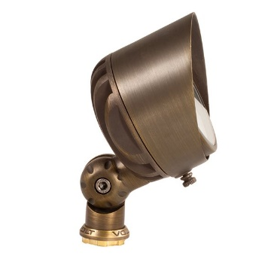

Photometrics

Light Source: Single Source Cree® LED's with 4-step binning

Light Output: (Board Lumens)850 Lumens

Light Output: (Fixture)650 Lumens

Optics: 60º wide flood optic (pre-installed), 17°, 24°, and 35º flood optics (optional)

Color: Temperature (CCT)2700K warm white

Lamp Life: (L70)60,000 hr

Certifications

UL & cUL Listed

Warranty: Lifetime

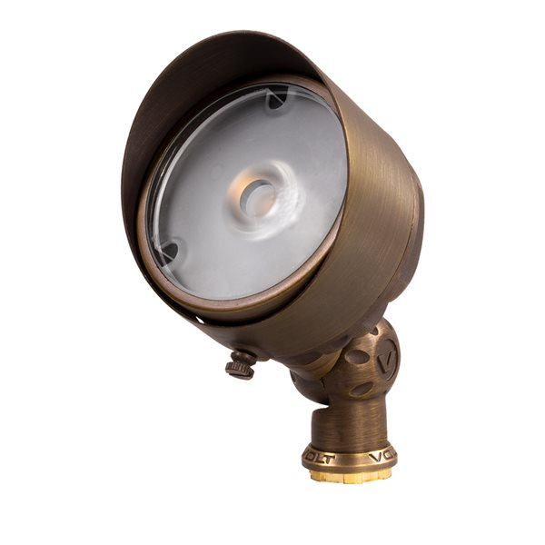

Electrical

Energy Consumption: (watts)12 watts

Power: FactorNA

Operating Voltage: Range6-18VAC

Power Supply: VOLT® Low Voltage Transformer (sold separately)

Installation

Orientation Directed upwards only

##### **Description**

• Advanced knuckle designed for precise aiming and locking in position.

• Interchangeable optics so beam angles can be changed in the field.

• 60º Optic (pre-installed) ideal for medium-to-wide flood applications. Easy-change to 17°, 24°, and 35º Optics (sold separately).

• High-performance Cree® LED's with 4-step binning for color consistency and longevity.

• Cast brass construction with Antique Bronze finish for lifetime durability.

• Extremely robust moisture protection (thick O-ring and silicone plugs) to prevent water intrusion and corrosion.

• Light Output (Board Lumens): 850 Lumens

• Light Output (Fixture): 650 Lumens

• 2700K warm white color temperature

• Completely sealed to an IP (Ingress Protection) Rating of 65. (The first number is for solid intrusion and is a scale from 1-6 with 6 being the highest. It means even the smallest dust partials cannot enter the fixture over time. The second number stands for the water intrusion rating. The "5" means that even when the fixture was tested with powerful water jets there was no water intrusion.)

• Lifetime warranty

Save time, money, and energy with these high-performance LED landscape lighting spotlight

#### Infiniti™ 60 G3 Aluminum LED Spotlight

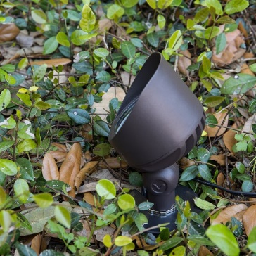$44.97

##### **Technical Details**

Product code : MKIO-9998

Materials

ConstructionAluminum

FinishBronze

Lead Wire4' or 25' UL certified 18AWG, SPT-1 premium tinned copper wire

LensClear flat glass

MountingIncludes 10" Hammer™ stake with cutout for wire exit

DimensionsEntire Fixture: 5.65" x 3.35" Shroud 3" x 3.35" Body: 5.65" x 3.35" Stake: 10" x 3"

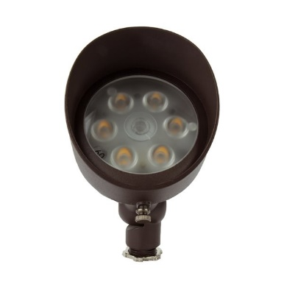

Photometrics

Light Source: Cree® LED's with 4-step binning

Light Output: (LED Array)1000 Lumens

Light Output: (Fixture)800 Lumens

Optics: 60º wide flood optic (pre-installed), 35º flood optic (optional)

Color Temperature: (CCT)2700K warm white

Lamp Life: (L70)60,000 hr

Certifications

CertificationsUL & cUL Listed

Warranty 5 Year

Electrical

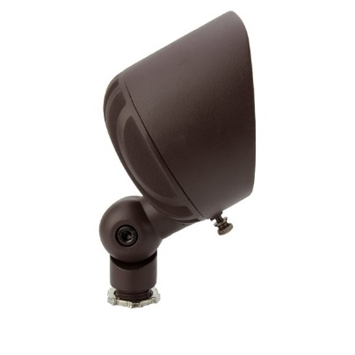 Energy Consumption: (watts)18 watts

Power Factor: NA

Operating Voltage: Range6-18VAC

Power Supply : VOLT® Low Voltage Transformer (sold separately)

Installation

Orientation Directed upwards only

##### **Description**

• New Improved knuckle design for precise aiming and locking in position.

• Interchangeable optics so beam angles can be changed in the field.

• 60º Optic (pre-installed) ideal for medium-to-wide flood applications. Easy-change to 35º Optic (sold separately).

• High-performance Cree® LED's with 4-step binning for color consistency and longevity.

• High-quality aluminum construction with super-durable powder coated finish.

• Extremely robust moisture protection (double O-rings and silicone plugs) to prevent water intrusion and corrosion.

• Light Output (LED Array): 1000 Lumens

• Light Output (Fixture): 800 Lumens

• 2700K warm white color temperature

• Completely sealed to an IP (Ingress Protection) Rating of 65. (The first number is for solid intrusion and is a scale from 1-6 with 6 being the highest. It means even the smallest dust partials cannot enter the fixture over time. The second number stands for the water intrusion rating. The "5" means that even when the fixture was tested with powerful water jets there was no water intrusion.)

• 5-year warranty

#### Glitz 7WSPWH 6W 6500K Finest Quality Led Spot Light (Cool White)

$165.90

##### **Technical Details**

Product Code: BAOP-0099

Brand: Glitz

Height: 13 Centimeters

Length: 13 Centimeters

Width: 6.5 Centimeters

Weight: 599 Grams

Number of Items: 1

Style: Modern

Colour: Cool white

Shape: Round cylindrical

Material: Metal

Number of Lights: 1

Included Components: Bulb included, Light kit included, Shade protector

Voltage: 220 Volts

Fixture Features: Save power reduce electrical expenses., 30,000 burning hours of life span., Adjustable Neck for spotting mostly everywhere around where it gets fixed.

Shade Colour: Cool white

Lampshade Diameter: 2 Inches

Power and Plug Description: corded-electric

Batteries Included: No

Batteries Required: No

Type of Bulb: LED

Wattage: 6 Watts

Start Up Time: Instant full light

Lamp Power Factor: 0.6

##### **Description**

• ✔ Led spot light, 6w electricity consumption, give light approx of 50w bulb, for indoor use.

• ✔ Round, light Have a reflector for brighter light, Led life is 30000 hrs

• ✔ Package content:- Led Fitting everything inbuilt.

• ✔ Diemension:- 130*130*65cm

• All inclusive of light fitting and driver, can be directly pulg in to 220v

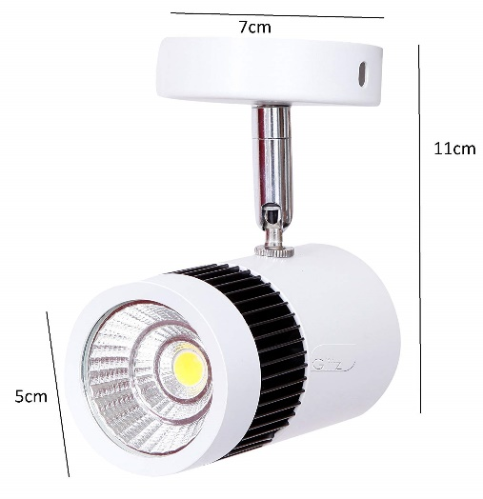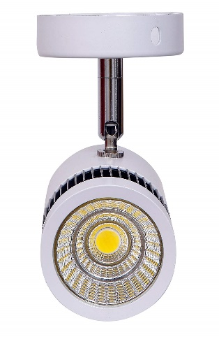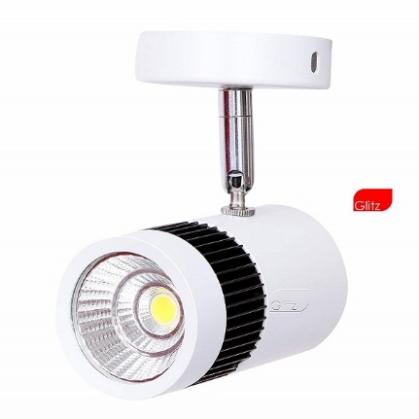

#### Mr. Beams MB360XT-WHT-01-00 LED Spotlight (White)

$172

##### **Technical Details**

Product code: O9KI-0775

Brand: Mr. Beams

Height: 16.5 Centimeters

Length: 8.9 Centimeters

Width: 11.2 Centimeters

Weight: 249 Grams

Number of Items: 1

Style: Modern

Colour: White

Material: Plastic

Number of Lights: 1

Included Components: 1 Wireless Spotlight, Mounting Base, 3 Screws, 3 Anchors, User Manual

Voltage: 6 Volts

Shade Material: Plastic

Power and Plug Description: Battery-Powered

Batteries Included: No

Batteries Required: Yes

Type of Bulb: LED

Luminous Flux: 200

##### **Description**

• Includes: LED Spotlight

• Warranty: 1 year on product from date of invoice

• This next generation battery LED spotlight provides 200 lumens of bright outdoor security lighting

• Its unique reflective face spreads the light to create a wider coverage area, making it ideal for large areas

• The bold, durable, weatherproof design allows it to be used as a reliable outdoor spotlight

• Motion activation, auto shut off and a light sensor help to prolong battery life, expect about 1 year of light on each set of batteries with average use of 8-10 activations a day

• Install the wireless, battery-powered light anywhere around the home and yard in less than 5 minutes - no electrician needed

#### Mr. Beams MB310 80-Lumens Wireless Mini LED Spotlight with Motion Sensor and Photocell (Small, Brown)

$174

##### **Technical Details**

Product code: MB310

Brand: Mr. Beams

Area Lighting Classification: IP44

Height: 8.9 Centimeters

Length: 8.9 Centimeters

Width: 10.2 Centimeters

Weight: 136 Grams

Style: Modern

Colour: Brown

Shape: Round

Material: Other material

Number of Lights: 1

Included Components: 1 Spotlight

Voltage: 4.50 Volts

Power and Plug Description: battery-powered

Batteries Included: No

Batteries Required: Yes

Type of Bulb: LED

##### **Description**

• Extremely bright LED with minimum power consumption, 80 Lumens of light

• Detects motion from up to 30-feet away and 30 seconds per activation

• Motion sensor turns LED spotlight on and off automatically

• Built-in light sensor guarantees activation after dark to conserve battery life

• Weatherproof design for durability, Mr. Beams mini LED spotlight for indoor or outdoor use

• Simple wireless installation in minutes, no need for an electrician

• Mounts to any flat surface, point this LED spotlight in any direction

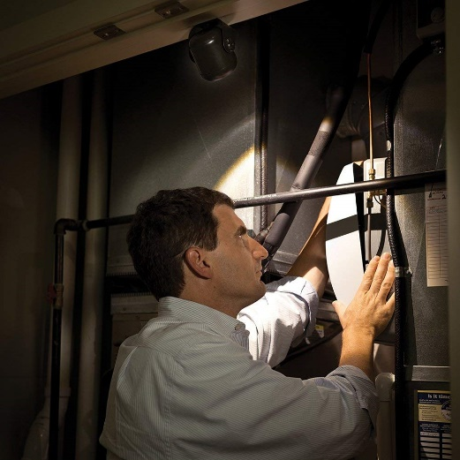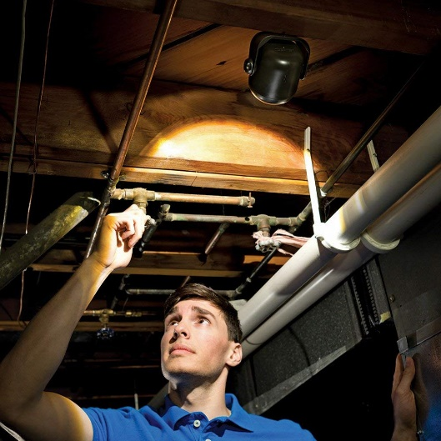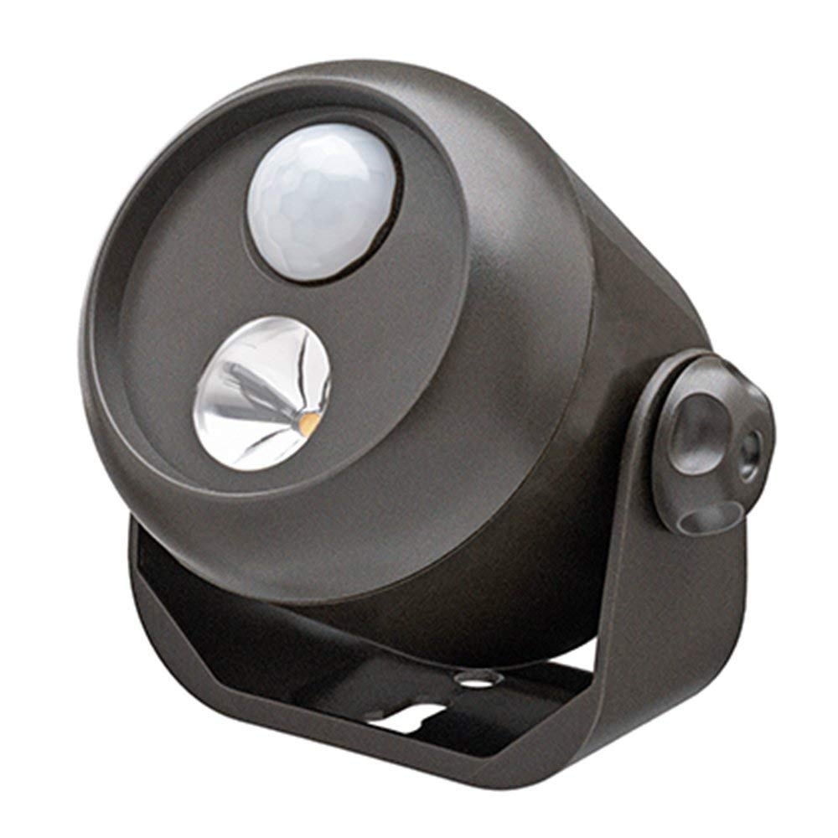

#### Mr. Beams MB3000-WHT-01-00 LED Dual Head Security Spotlight (White)

$199

##### **Technical Details**

Product code: MB3000-WHT-01-00

Brand: Mr. Beams

Height: 10 Centimeters

Length: 27.1 Centimeters

Width: 9.2 Centimeters

Weight: 390 Grams

Number of Items: 1

Style: Modern

Colour: White

Material: Plastic

Number of Lights: 1

Included Components: 1 Wireless LED Dual Head Security Spotlight, 3 Screws, 3 Anchors, Mounting Bracket, User Manual

Voltage: 6 Volts

Shade Material: Plastic

Power and Plug Description: Battery-Powered

Batteries Included: No

Batteries Required:Yes

Type of Bulb: LED

Luminous Flux: 500

##### **Description**

• Includes: LED Dual Head Security Spotlight

• Warranty: 1 year on product from date of invoice

• The dual head spotlight provides 500 lumens of bright light for large, dark areas

• Customise the bright LED light coverage area with two adjustable heads that pivot 185 degrees up and down and 135 degrees side to side

• The LED security light activates when it detects motion from 30 feet away and automatically shuts off 30 seconds after motion stops to prolong battery life

• Install the wireless LED spotlight in minutes with the included screws anywhere light is needed, including garages, doorways, sheds and fences

• The durable and weatherproof design make this wireless outdoor security spotlight ideal for outdoor use

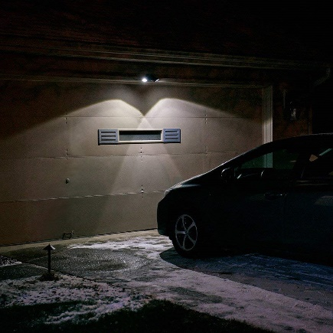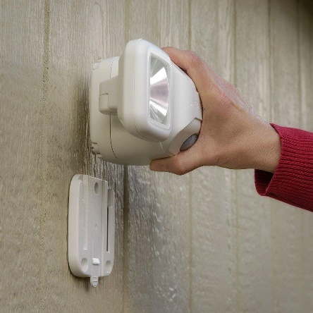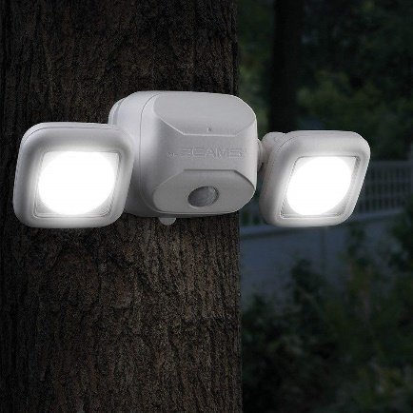

#### Glitz 2x10w Human sensor PIR led SPOT light, warm white 3000k, Motion sensor, IP65 outdoor

$138

##### **Technical Details**

Product code: 2X10W-PIR-WW

Brand : Glitz

Style: Comtemporary

Colour: Black

Shape: Rectangular

Material: Metal

Number of Lights: 1

Included Components: Bulb included, Light kit included, Shade included

Voltage: 220 Volts

Fixture Features: High lumens flood light with sensing infra red technology., Can be adjusted with different needs, Day and night, motion sensor., Heavy duty weather proof ip65

Shade Colour: Cool white

Shade Material: Glass

Power and Plug Description: corded-electric

Batteries Included: No

Batteries Required: No

Type of Bulb: LED

Wattage: 20 Watts

Colour Temperature: 6500 Kelvin

Start Up Time: Instant full light

##### **Description**

• ✔ CONTENT:- 1 pcs outdoor spot light, With sensor attached ready to use.. Dimension:- 6x6x7inch

• ✔ SPECIFICATION:- Round Fixture, Aluminium Body and Reflector, and also Waterproof driver Built in side, LED life 20,000 hours, 6500k cool white. Product is with 1 year warranty.

• ✔ USAGE:- There are Three Nobs behind the sensor, 1. Lux:- Which is to adjust the Day and Night mode. 2. Time:- to adjust cutoff time, when it turns on after turning ON how long will be ON for. 3. Sens:- is for adjusting the capability of sensing the object distance. Best for outdoor IP65, Garden, Lawn, Main gate entrance, Mostly installed for security and convenience purpose.

• ✔ PROTECTION:- Fixture is weatherproof IP65 ratings, which can stand any kind of weather, Like dusty, rainy, humid, cold, warm etc.

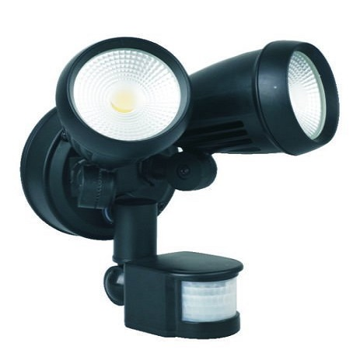• ✔ VARIANT:- Also available in Warm white color.

